Nursing care for people with COVID-19 in hospital: a clinical research study.
We would like to invite you to take part in a research study being undertaken in our hospital. This leaflet will explain the aims of the study and what this would involve for you. You will also get an opportunity to discuss this further with a research nurse before making your decision.
What is the study about?
Nursing care is hugely important to people in hospital. Nursing includes helping people with those essential and intimate tasks of life that we normally take for granted – washing, eating, cleaning, going to the toilet, etc. Nursing care makes a significant difference to the way people experience being in hospital and to their recovery. This is certainly true for people with COVID-19. However, the nature of the COVID-19 illness and the protective clothing worn by nurses has meant that nurses have had to change their day to day work.

In this study, we are testing a set of specific procedures that nurses can use to care for patients with COVID-19. We call this a nursing guideline – a type of blueprint for nursing patients with COVID-19. Our guideline is based on what nurses themselves have done to adapt the way they care for people. We have also had a lot of input from patients who have been nursed through their COVID-19 illness.
We are now conducting a type of scientific study called a randomised controlled trial. This will allow us to test these procedures to determine their effect on patient experience, care quality, patients’ ability to manage day to day activities, treatment outcomes and costs. Because we don’t know if they are any better than the procedures nurses normally use, half the nurses and hospitals in the study will implement the new way of working, half will continue to deliver nursing care as usual.

At the end of the study we will know how well these procedures meet the needs of patients in hospital with COVID-19. If the study is successful, we will be able to use the guideline across the NHS and even for hospitals in other countries.

Why have I been approached?
For this study we are approaching nurses and patients in hospital with COVID-19.
You have been approached to take part as you work in a hospital delivering nursing care to patients with COVID-19.

Do I have to take part?
No. It is entirely up to you to decide whether or not to take part by giving us your data. If you are working in a hospital that has decided to take part in the trial, you will be included in it at the site level – but you do not have to answer any questions for our outcomes. If you do decide to take part you will be asked to sign a consent form to allow us to record outcome data. You are free to withdraw at any time and without giving a reason but we will keep information about you that we already have. We need to manage your records in specific ways for the research to be reliable. This means that we won’t be able to let you see or change the data we hold about you. A decision to withdraw or not to take part will not affect your employment rights in any way.

What is involved in the study and what information will we need from you?
Once the study has started at the hospital where you work, you will be told whether your hospital has been randomly allocated to the ‘care as usual’ or intervention condition. Regardless of the condition to which your hospital has been allocated, a research nurse will speak to you about the study and will give you this information sheet. They will explain the study in detail and give you a chance to ask any questions.
You can be given some time to think about taking part and be able to discuss it with others. If you decide to take part a research nurse will ask you to sign a consent form and ask you to fill in a short questionnaire.
If you decide to take part, we will need to use information from you for this research project. This information will include your name, contact details and answers to be asked a series of questions on your experience of providing care. This questionnaire takes less than 20 minutes to complete. You may also be asked to take part in a short interview with follow up questions at the end of the 6 week trial period by a researcher. People who do not need to know who you are will not be able to see your name or contact details. Your data will have a code number instead. We will keep all information about you safe and secure. Once we have finished the study, we will keep some of the data so we can check results. We will write our reports in a way that no-one can work out that you took part in the study.
This is the entire assessment, and you will continue your nursing care with the same NHS clinical care standards as people not taking part in the study. Please also see the study flow chart which is included with this information

Interviews with a researcher
Semi structured interviews will be conducted with a sample of nurses and care staff who have been using the new guidelines and way of working. A topic guide formulated from the intervention content will be used during these interviews. We want to know your thoughts on aspects such as the impact and acceptability of the intervention and other aspects you think may be of interest to us. The interviews will be over the telephone or use online audio-conference methods and once an anonymised transcript has been created the recording will be permanently deleted. Face to face interviews may be considered if this is preferred by participant and the activity is risk assessed as being safe.

We will audio-record interviews with participants’ consent and transcribe interviews verbatim. The interviews will be conducted and transcribed by the core research team at the University of Exeter.

The transcripts of the interviews will be anonymised so no-one will know you have been interviewed. The interview transcripts will be anonymised by removal of name and any using the participant ID number only, and any reference to wards, patient names, or colleagues will be removed.

The transcripts will be stored on university laptops which are password protected and have encrypted drives during analysis and on servers all of which are in Europe Economic Area. At the end of the study the transcripts will be stored indefinitely on a research data storage system provided by the University of Exeter called Open access Research Exeter (ORE) for archiving

This diagram should help explain what will happen if you take part in the study:
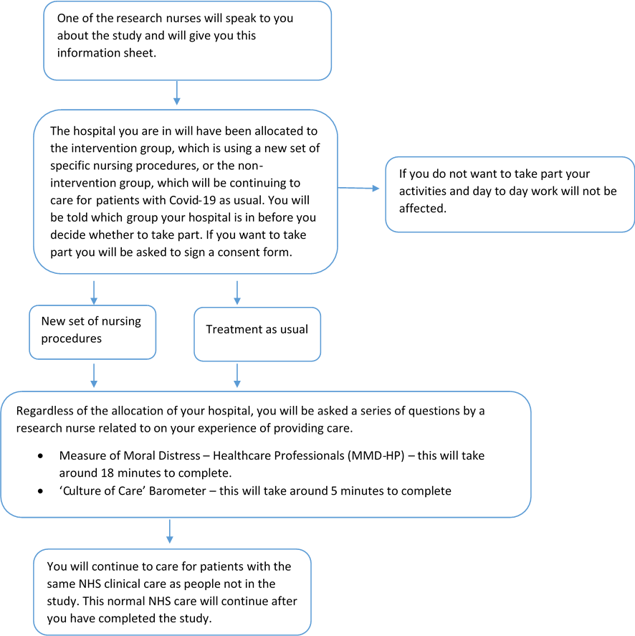

What are the possible risks and benefits of taking part?
Although you would not receive any monetary benefit for taking part, participating in research like this helps to improve future patient care. We do not foresee any serious additional risks in taking part in the study as the new protocol includes at least the same nursing care as the usual level of care. Randomisation is by hospital, and patient participants in the usual care hospitals will not see any reduction in the standard of their care.

Will my taking part in this study be kept confidential?
Information collected about you will be kept strictly confidential and in accordance with the Data Protection Act. The data recorded about you will be given a code and rendered anonymous in such a way that the data could not be used to identify you. Your personal identifying information, such as name and address, will be kept separately and not shared outside the trial team. The data will be stored on servers all of which are hosted in Europe. If any information that is disclosed when answering questions indicates there may be a potential for harm to others or yourself, your direct care team may be informed of this, for example your GP. This would be in accordance with local risk management procedures. However, this is the only time we would ever break confidentiality. Your anonymous data will be analysed by the research team and may be shared with the wider scientific community.

Who has reviewed the study?
All research in the NHS is looked at by an independent group of people, called a Research Ethics Committee to protect your interests. This study has been reviewed and was given favourable ethical opinion by North East- Newcastle & North Tyneside 2 Research Ethics Committee
What will happen to the results of this study?
The results of the study will be available after it finishes and will be published in a health care journal and be presented at scientific conferences. We will also publish results in other formats to ensure patients and members of the public can access our findings. The data will be anonymous and none of the participants involved in the trial will be identified in any report or publication. Should you wish to see the results, or the publication, please ask your research nurse or site principal investigator.
What if there is a problem?
If you have a concern about any aspect of this study, you should ask to speak with the researchers who will do their best to answer your question. If you remain unhappy and wish to complain formally, you can do this through the University of Exeter Complaints Procedure by contacting the Sponsor Representative, Pam Baxter, Senior Research Governance Officer, by telephone 01392 723588 or email p.r.baxter2@exeter.ac.uk.

In the event that something does go wrong and you are harmed during the research study there are no special compensation arrangements, however, if you are harmed and this is due to someone’s negligence then you may have grounds for a legal action for compensation, but you may have to pay your legal costs. The normal National Health Service complaints mechanisms will still be available to you.

Contact for further information
You are encouraged to ask any questions you wish, before, during or after your participation. If you have any questions about the study, please speak to your Research Nurse or contact our Research Coordinator, Leila Morgan on L.Morgan@exeter.ac.uk

If you require independent advice or you have any concerns while taking part in the study please contact the Sponsor Representative, Pam Baxter, Senior Research Governance Officer, by telephone 01392 723588 or email p.r.baxter2@exeter.ac.uk

General Data Protection Regulation (GDPR)
The University of Exeter is the sponsor for this study based in the United Kingdom. We will be using information from you and your medical records in order to undertake this study and will act as the data controller for this study. This means that we are responsible for looking after your information and using it properly. The University of Exeter will keep identifiable information about you for 5 years after the study has finished. Your rights to access, change or move your information are limited, as we need to manage your information in specific ways in order for the research to be reliable and accurate. If you withdraw from the study, we will keep the information about you that we have already obtained. To safeguard your rights, we will use the minimum personally-identifiable information possible.

The University of Exeter via the Exeter Clinical Trials Unit (ExeCTU) will keep identifiable information about you from this study for 5 years after the study has finished.

Where can you find out more about how your information is used?
You are encouraged to ask any questions you wish, before, during or after your participation. You can find out more about how we use your information by:
- Visiting www.hra.nhs.uk/information-about-patients/
- This online leaflet www.hra.nhs.uk/patientdataandresearch
- By asking one of the research team
- By sending an email to our Research Coordinator, Leila Morgan on L.Morgan@exeter.ac.uk
- By ringing the sponsors representative Ms Pam Baxter on 01392 723588

If you have any questions about the study, please speak to your Research Nurse or contact our Research Coordinator, Leila Morgan on L.Morgan@exeter.ac.uk

If you require independent advice or you have any concerns while taking part in the study please contact the Sponsor Representative, Pam Baxter, Senior Research Governance Officer, by telephone 01392 723588 or email p.r.baxter2@exeter.ac.uk

Complaints procedure

If you have a concern about any aspect of this study, you should ask to speak to the researcher at the University of Exeter who will do their best to answer your questions on 07814819021. If you remain unhappy and wish to complain formally, you can do this by contacting either the Sponsor’s Representative, Ms Pam Baxter by telephone 01392 723588 or email p.r.baxter2@exeter.ac.uk or contact the Patient Advice and Liaison Service (PALS) who can provide confidential support and information and can advise on the NHS complaints procedure. Your nearest PALS can be found by asking your hospital or GP surgery or calling NHS 111

If you decide you would like to take part then please read and sign the consent form. You will be given a copy of this information sheet and the consent form to keep. A copy of the consent form will be filed with the study records and one may be sent to the Research Sponsor (The University of Exeter).
Thank you for taking the time to read this information sheet and to consider this study

