ETBP SPANISH 2015
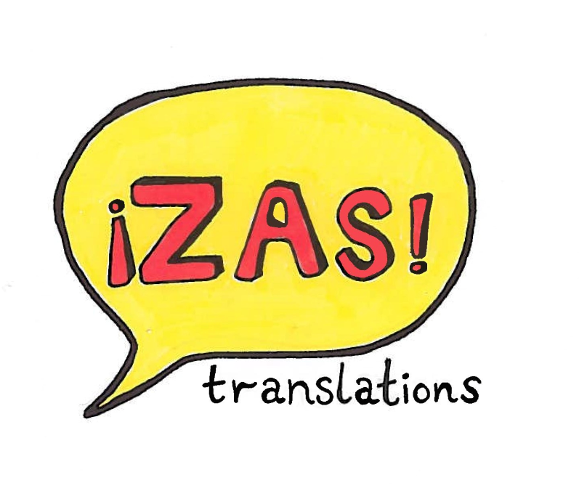

Ross Britcher – Kezia Cochrane – Rosie Lewis – Anjali Mukhi – Caroline Seng – Ellie Weekes – Rebecca White
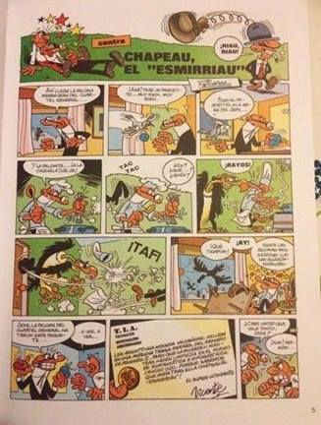
Mortadelo y Filemón

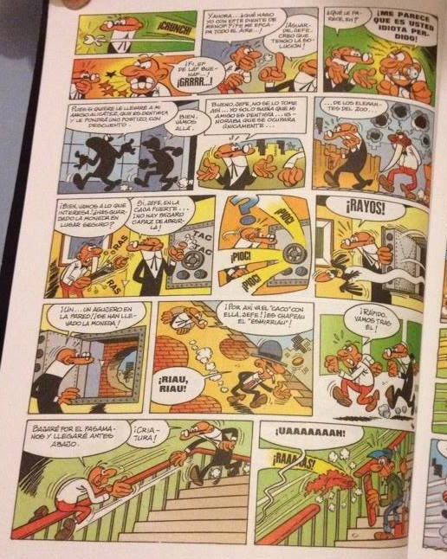

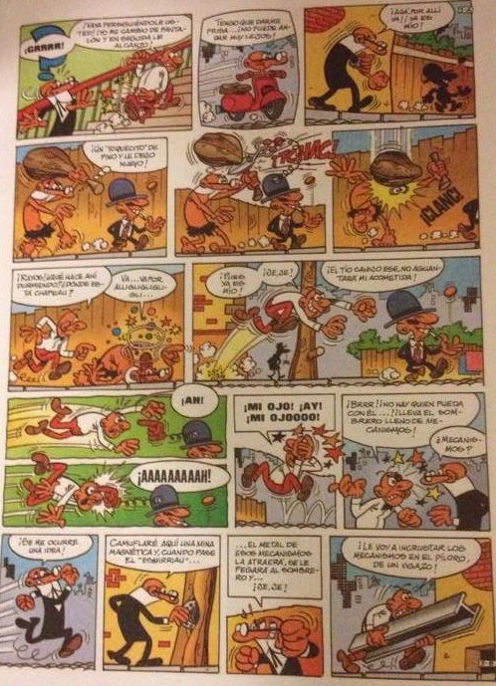

Mortadelo
Francisco Ibañez
Page | Box | Bubble/background | Translation
1 | TITLE | 1 | CHAPEAU THE SCRAWNY
 |  | 2 | Mwahaha!
 | 1 | 1 | Here comes the messenger pigeon from the military headquarters…
 | 2 | 1 | Aha! He’s brought a small package…very good, very good.
 | 3 | 1 | So the package on the boss’ desk…
 | 4 | 1 | And the pigeon…in the cooking pot! Hehe!
 | 5 | 1 | KNOCK KNOCK.
 |  | 2 | Eh? What..? Who?
 | 6 | 1 | YIKES!
 | 7 | 1 | BUFF!
 | 8 | 1 | These crazy times!
 |  | 2 | Ow!
 |  | 3 | Even messenger pigeons have bodyguards.
 | 9 | 1 | Boss, the pigeon from the military headquarters has delivered this package…
 |  | 2 | Let’s see, let’s see…
 | 10 | 1 | T.A.I. Technical Aeroterrestrial Investigation.  I enclose this extremely valuable coin from Rameses II’s reign, found in a slot machine, for you to look after whilst they clean the numismatic and hypogastric museum. Take great care, because we know that ‘Chapeau the Scrawny’ is after it!  Superintendent  Vicente.
 | 11 | 1 | Do you really think it’s worth much, boss?
 |  | 2 | Hmm, let’s see…
2 | 1 | 1 | CRUNCH!
 |  | 2 | Yeth, ith a good one…GRR!
 | 2 | 1 | And now…what do I do about thith mithing tooth? Ith making me lithp..!
 |  | 2 | Hold on, boss, I think I have the solution!
 | 3 | 1 | What do you think, eh?
 |  | 2 | I THINK YOU ARE A HOPELESS IDIOT.
 | 4 | 1 | Well, if you want I can take you to my friend Alicátez, he’s a dentist and he’ll give you a filling with a discount.
 |  | 2 | Fine, let’s go there.
 | 5 | 1 | Well, boss, don’t be like that…I only knew that my friend is a dentist…I wasn’t aware that he dealt solely…
 | 6 | 1 | …with elephants from the zoo…
 | 7 | 1 | Whatever, back to what’s important! Have you put the coin in a safe place?
 |  | 2 | Yes, boss, in the safe…there isn’t a bird that could open it!
 | 8 | 1 | Click click…
 | 9 | 1 | YIKES!
 | 10 | 1 | A… A hole in the wall! The coin’s been taken!
 | 11 | 1 | There goes the ‘thief’ with it! It’s Chapeau the Scrawny!
 |  | 2 | Mwahaha!
 | 12 | 1 | Quick, follow him!
 | 13 | 1 | I’ll slide down the bannister and reach the bottom first.
 |  | 2 | You beast!
 | 14 | 1 | ARGGGGH!
 |  | 2 | RIIIIIP!
3 | 1 | 1 | GRRRR!
 |  | 2 | Go on run after him! I’ll change my trousers and catch you up right away!
 | 2 | 1 | I need to hurry…He can’t have got far!
 | 3 | 1 | Aha! There he goes! Now he’s mine!
 | 4 | 1 | A ‘light knock’ of wood and I’ll leave him again…
 | 5 | 1 | SNIP!
 | 6 | 1 | CRUNCH!
 | 7 | 1 | Yikes! What are you doing sleeping there? Where is Chapeau?
 |  | 2 | He he’s over thererererere…
 | 8 | 1 | Well, now he’s mine!
 |  | 2 | Hehe!
 |  | 3 | This feeble fellow, he won’t survive my attack!
 | 9 | 1 | Ah!
 |  | 2 | AAAAAH!
 | 10 | 1 | MY EYE! OW! MY EYE!
 | 11 | 1 | Brrr! No one can mess with him…! His hat is full of gadgets
 |  | 2 | Gadgets?
 | 12 | 1 | I have an idea!
 | 13 | 1 | I’ll hide a magnetic landmine and when Scrawny passes by…
 | 14 | 1 | … It will attract the metal from those gadgets, stick to his hat and…hehe!
 | 15 | 1 | I’m going to drive those gadgets into his stomach with this beam!

Mafalda
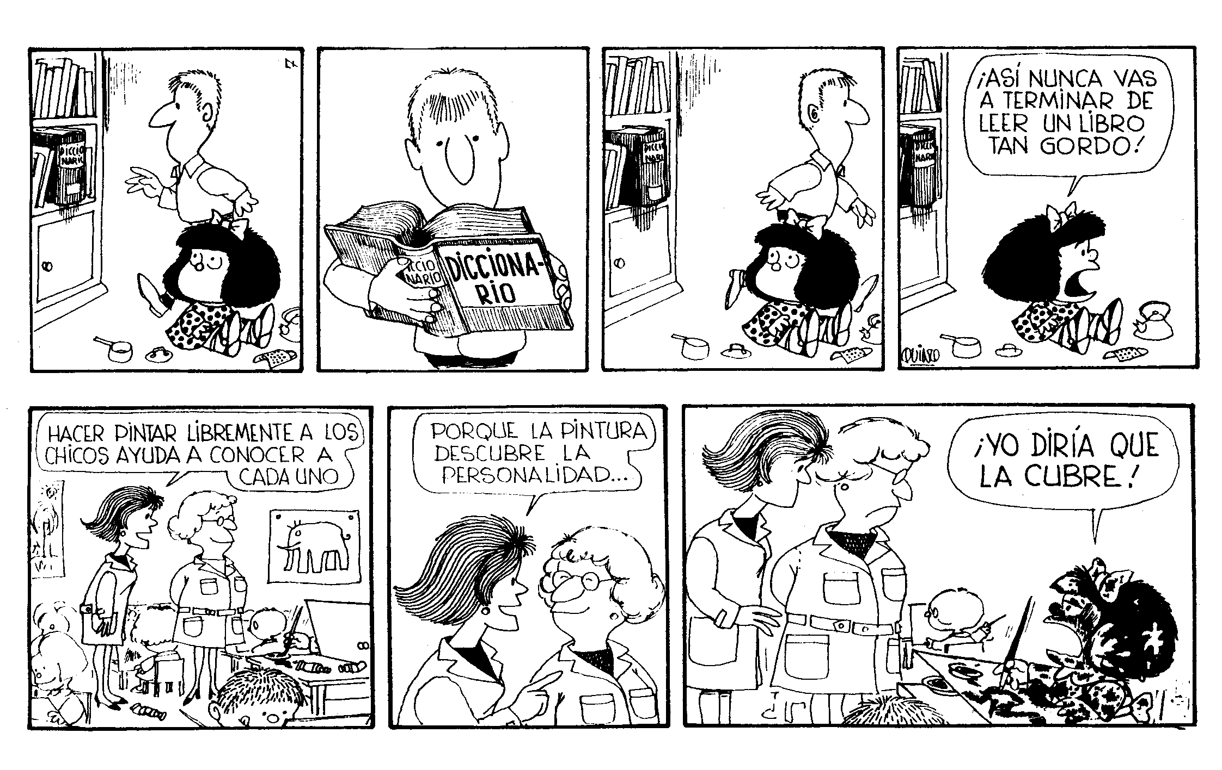
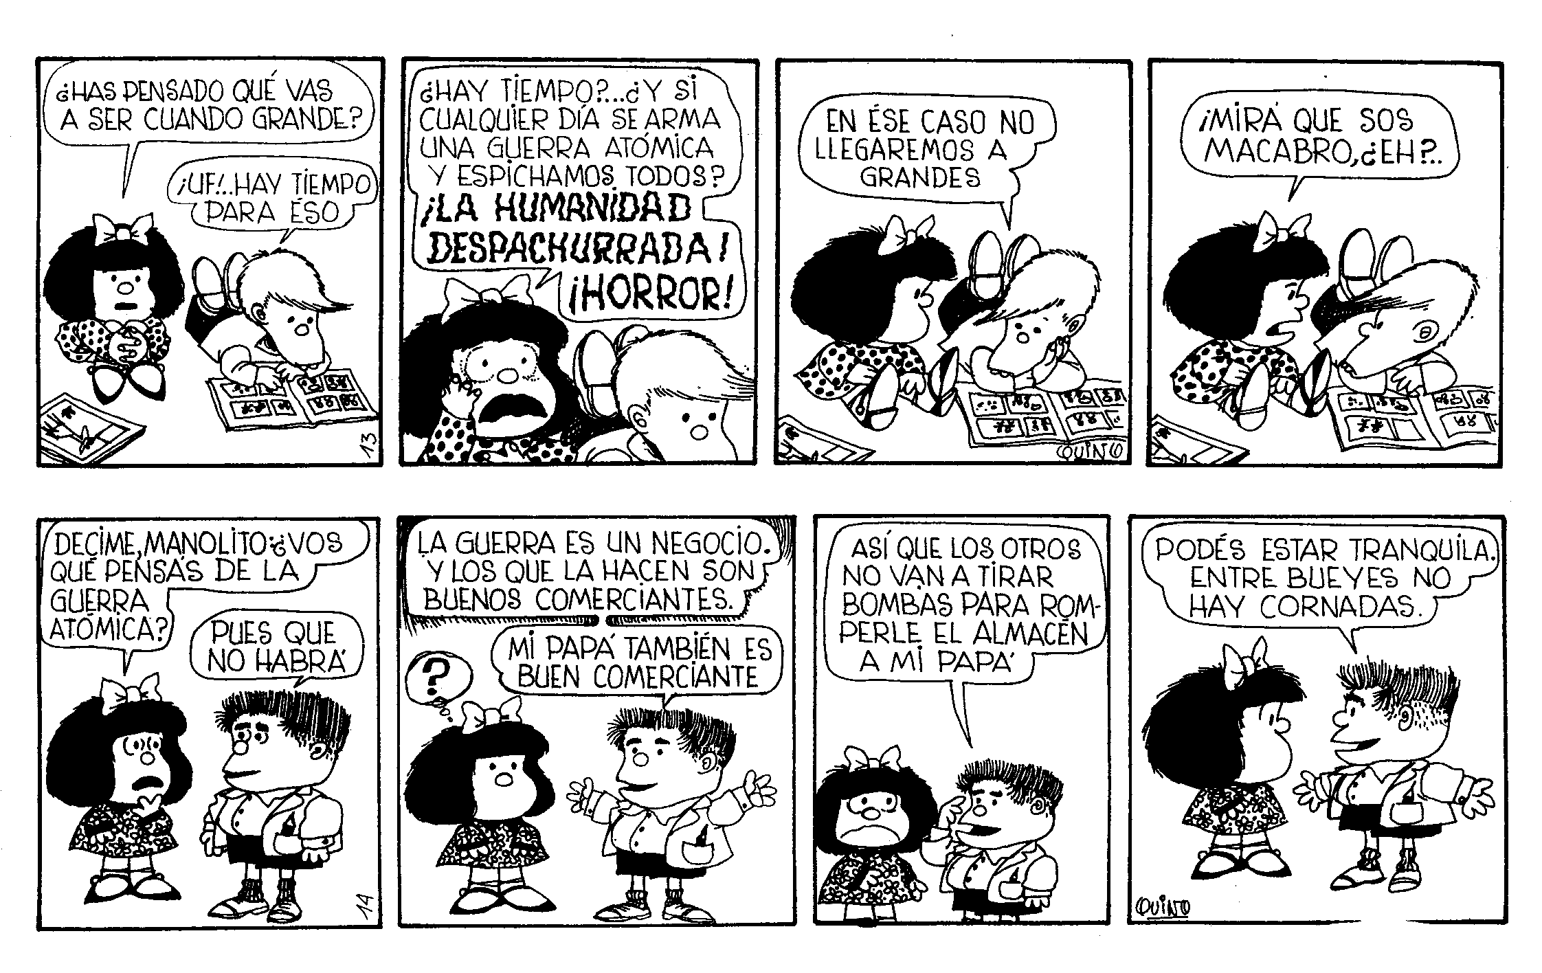

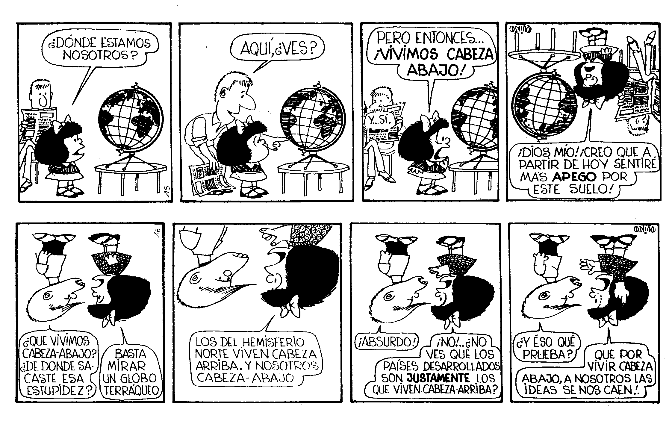

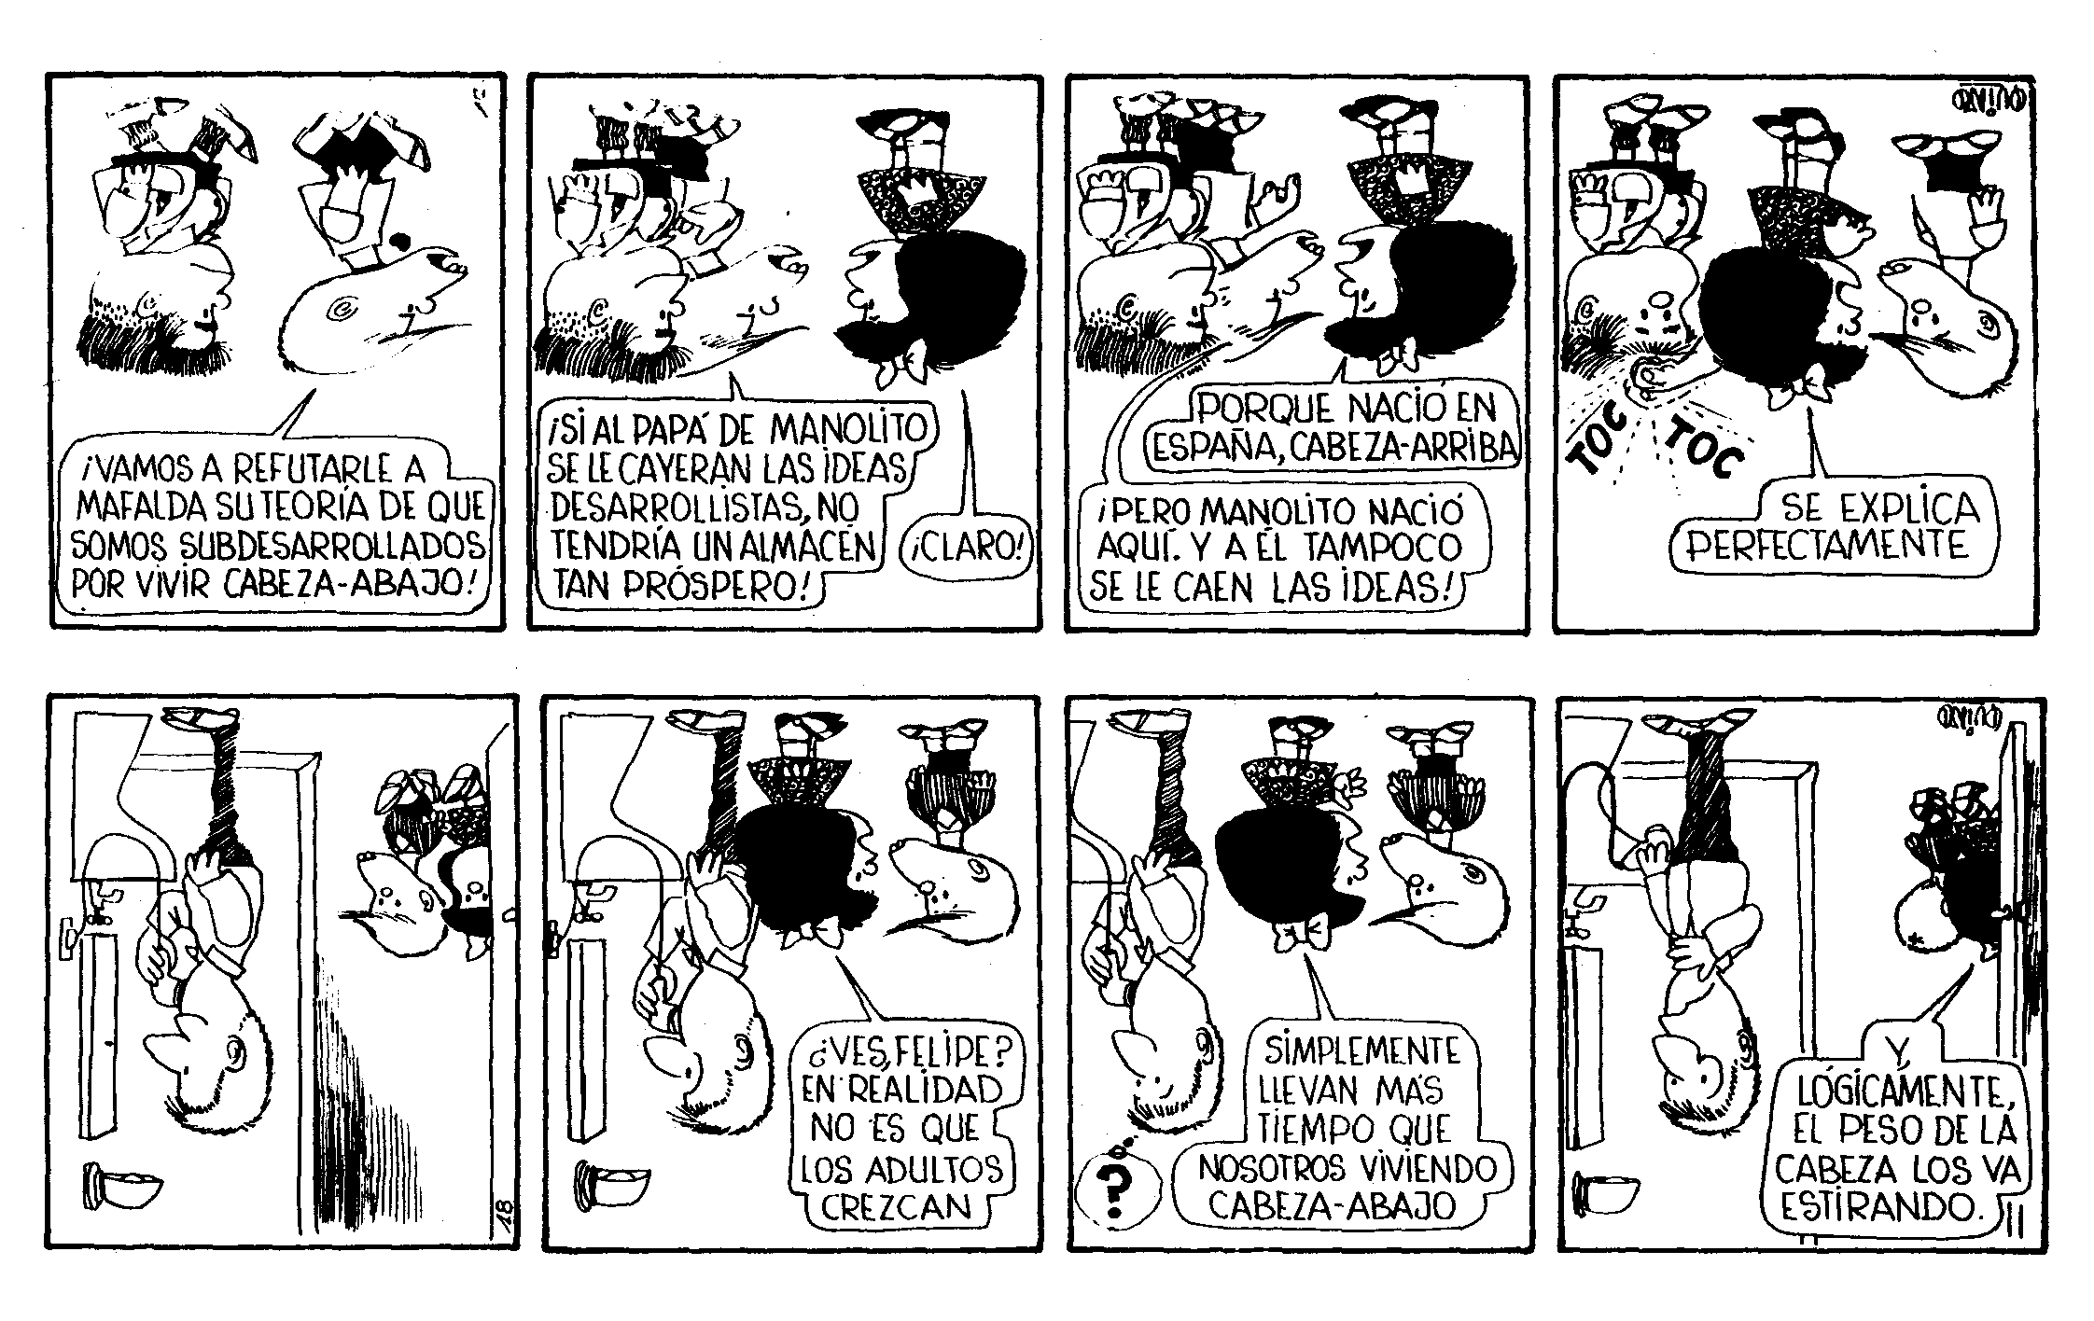

Mafalda

Strip | Box | Speech Bubble | Translation
1 | 2 | 1 (book) | DICTIONARY
 | 4 | 1 | You’ll never finish reading such a big book like that!
2 | 1 | 1 | Getting the children to paint freely helps you get to know them all
 | 2 | 1 | Because painting uncovers your personality
 | 3 | 1 | I would say it covers it up!
3 | 1 | 1 | Have you thought what you’re going to be when you’re a grown-up?
 |  | 2 | Ugh! There’s still plenty of time for that
 | 2 | 1 | There’s still time? What if one day there’s an atomic war and we’re all goners? Humanity crushed! The horror!
 | 3 | 1 | Well in that case we won’t grow up
 | 4 | 1 | How gloomy you are…
4 | 1 | 1 | Tell me, Manolito, what do you think about atomic war?
 |  | 2 | That there won’t be one.
 | 2 | 1 | War is a business, and those who start it are good businessmen.
 |  | 2 | My daddy is a good businessman too
 |  | 3 | ?
 | 3 | 1 | So the rest aren’t going to drop bombs and destroy my daddy’s shop
 | 4 | 1 | You can relax. There’s honour amongst thieves.
5 | 1 | 1 | Where are we?
 | 2 | 1 | Here, see?
 | 3 | 1 | But then… we live upside-down!
 | 4 | 1 | Oh my God! After today I think I’ll feel much more attached to the ground!
 | 5 | 1 | We live upside-down? Where did you get that stupid idea from?
 |  | 2 | You only need to look at a globe.
 | 6 | 1 | The people in the Northern Hemisphere live the right way up. And we live upside-down
 | 7 | 1 | That’s crazy!
 |  | 2 | No! Don’t you see? The developed countries are precisely those that live the right way up?
 | 8 | 1 | So what?
 |  | 2 | So by living upside down, the ideas fall out of our heads!
 | 9 | 1 | Let’s go and disprove Mafalda’s theory that we’re underdeveloped because we live upside-down!
 | 10 | 1 | If Manolito’s daddy’s developmental ideas fell out of his head, he wouldn’t have such a successful shop!
 |  | 2 | Of course!
 | 11 | 1 | It’s because he was born in Spain, the right way up
 |  | 2 | But Manolito was born here, and ideas don’t fall out of his head either!
 | 12 | 1 | It makes perfect sense
 |  | 2 (background) | Knock knock
 | 14 | 1 | Do you see, Felipe? Adults don’t actually grow
 | 15 | 1 | They simply spend more time than we do living upside-down
 |  | 2 | ?
 | 16 | 1 | And, logically, the weight of their heads makes them stretch.
6 | 4 | 1 | What part of society do cats belong to?

Blacksad

Blacksad: A place in the shadows
Script: Juan Díaz Canales
Graphics: Juanjo Guarnido

Page | Window | Box | Translation
1 | 1 | 1 | Some mornings, it is harder to digest breakfast than others. Especially when the day greets you with the corpse of a past lover.
 | 2 | 1 | … The spoils of a beautiful dream.
 |  | 2 | Do you recognise her?
 | 4 | 1 | Yes. Have you got anything yet?
 |  | 2 | No, absolutely nothing; no weapon, no mobile, no suspect.
2 | 1 | 1 | I thought that maybe you would be able to help us.
 |  | 2 | It's been a long time since we saw each other.
 |  | 3 | Too long…
 | 2 | 1 | Fine. Thanks very much for coming. You can leave now.
 |  | 2 | From what I can see, this doesn't look like a theft.
 | 3 | 1 | For everyone's sake, do me a favour and keep your nose out of this.
 | 4 | 1 | Do you understand me, Blacksad?
 | 5 | 1 | Go to hell, Smirnov.
3 | 1 | 1 | Sometimes, when I go into my office, I get the impression I’m walking through the ruins of an ancient civilization. Not because of its untidy and chaotic appearance, but rather because there remain traces of the civilised being that I was.
 | 2 | 1 | But now that’s all part of the past, a past that stares back at me from the front page of the newspaper.
 | 3 | 1 | A star.
 | 4 | 1 | The day I met Natalia, I didn’t encounter that dazzling shine that one expects of a star. On the contrary, her face looked quite pale.
 | 5 | 1 | The pallor of fear.
4 | 1 | 1 | It struck me as odd that someone would worry about receiving so many tokens of affection and devotion from their admirers.
 | 2 | 1 (Note) | Whore, enjoy your final days.
 |  | 2 (Note) | To the most beautiful future corpse.
 |  | 3 | Until I read those notes.
 | 3, 4, 5 | 1 | It was a question of undertaking a task discreetly and efficiently. I can be extremely discreet when I take pains to be so, and above all ,
 | 6 | 1 | Very efficient.
5 | 1 | 1 | She was delighted with the results.
 | 2 | 1 | So much so that she wouldn’t do without my services.
 | 3 | 1 | It was the happiest time of my life.
6 | 1 | 1 | There was nothing mysterious about her. She was just an ordinary person with her own problems, passions…
 | 2 | 1 | …worries…
 | 3 | 1 | … and weaknesses…
 | 4 | 1 | And as nobody is perfect, and love á la carte does not exist…
 | 5 | 1 | …The circumstances defeated us and ended up driving us apart.

Capitán Trueno

Captain Thunder – MORGAN’S SECRET

Page | Window | Box | Translation
1 | 1 | 1 | Our friends only just had time to turn tail and try to flee… the terrible ‘thing’ was heading towards them! What tragic series of events had led them to such a dramatic situation?
 |  | 2 | Hurry! The THING is gaining on us!
 |  | 3 | Episode 1
 | 2 | 1 | It all began some days before, when…
 |  | 2 | We’ll spend the night here, and early tomorrow…
 | 3 | 1 | …We’ll continue our journey towards our old friend Morgan the magician’s castle
 | 4 | 1 | There’s no doubt that we owe some of our greatest journeys to him. Without his marvellous hot air balloon, the plans for which he confided in us a long time ago, we never would have made it this far.
 |  | 2 | His daughter Grune is very nice! And I hope that in the castle…
 | 5 | 1 | …They still have the same cook!
 | 6 | 1 | Our friends stop outside the coaching inn…
 |  | 2 | Yum! Speaking of cooks… This place doesn’t smell bad at all!
 | 7 | 1 | …And they go inside. Captain Thunder is unceasingly surprised by the immediate hostility of the diners…
 |  | 2 | Hey! Innkeeper!
 |  | 3 | Hello… You couldn’t say there’s a good atmosphere in here…
2 | 1 | 1 | Give us one of your finest tables! And bring us a nice dinner. We’re friends of Morgan the magician, who you’ll have heard of no doubt…
 | 2 | 1 | Just as the Nutcracker says those words, a deathly silence falls in the inn… And the unpleasant glares get worse…
 |  | 2 | By the great green frog! What’s up? It’s as if I’d mentioned the devil!
 | 3 | 1 | You’ve just done that by mentioning that Morgan!
 |  | 2 | Morgan is our friend, and I stand by him…
 | 4 | 1 | We’ll see if you’re still standing after this!
 |  | 2 (background) | CRACK!
 | 5 | 1 | Is that all you’ve got?
 |  | 2 | You… You didn’t fall!
 | 6 | 1 | Sirs! Gentlemen! Take pity! Don’t destroy my…
 | 7 | 1 | No! I can do more!
 |  | 2 | Ahhh!
 |  | 3 | Poor aim, my friend!
 | 8 | 1 | What a hit!
 |  | 2 | Poor guy…! But… what’s going on here? Why has it made everyone so angry hearing the name Morgan?

Invoice
