Abstract submission template, Arial, bold, 12 pt, do not use all caps
Paul S. Keatley,^{1*} Volodymyr V. Kruglyak,¹ Gino Hrkac,² Tom H. J. Loughran,¹ and Robert J. Hicken¹
- Department of Physics and Astronomy, University of Exeter
- College of Engineering, Mathematics, and Physical Sciences, University of Exeter
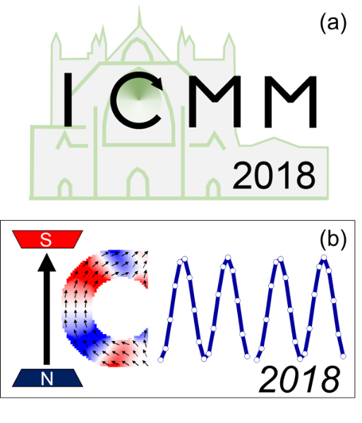
This is the abstract body. Margins for this template are 2.5 cm, please do not modify. Please use this template to generate your abstract for ICMM 2018. No editing will be carried out after you submit your abstract, so please follow this guide and ensure that your abstract does not exceed 1 page. The title font is Arial, bold, 12 pt, left aligned. Please do not use all caps for the title. Please list the authors in the style shown above using Arial 11 pt, not bold or italic, left aligned. Please provide full forename and surname, and any middle initials. Please underline the presenting author name and place * next to the corresponding author. Please use superscript Arabic numerals (starting at 1) to indicate the affiliation of each author. Please note the use of a comma before the superscript numeral, and a space following the numeral, to separate the authors in the author list. Beneath the author list, please list the department and institution of each author. The affiliation list should contain a number of affiliations that correspond to the Arabic numerals used in the author list. The affiliation list uses Arial 10 pt, and italics, left aligned. The abstract body should be Arial 11 pt, not bold or italic, justify alignment, single line spaced, and of a reasonable length (~300 words) to fit well within a single side of A4, with no changes to the layout style of this template. If the layout style is modified to fit abstracts of excessive length, the organisers may return the abstract. The freedom to use the full page permits authors to upload a single figure to the abstract, Figure 1. Authors are free to move the figure into the body of the text using the square text wrapping. Please ensure that text, plots, and images of the figure are legible, Fig. 1(a). Please include a figure caption in the style shown below. The Caption should be brief and in Arial, 9 pt and in italics to stand out from the main text. Finally, please include a small number of references [1], as necessary [2], in the style shown below [3]. Note that references in the abstract body should use square brackets. Please use square brackets in the reference list for the corresponding references. The reference list should include lead author, use standard journal abbreviations, volume (in bold), page number, and year (in parentheses) as shown.
Figure 1. (a) Current ICMM 2018 logo. (b) An alternative version of the ICMM 2018 logo. Please clearly label sub-figures with a letter in parentheses, i.e. (a) and (b). Please delete if not required for your abstract. Text is Arial, font 9 pt and italics. Use square text wrapping for figures.
Acknowledgements
ICMM2018 conference is sponsored by the IEEE.
References
[1] P.S. Keatley, Journ. Magn. Magn. Mater. vol, page (year).
[2] A.N. Other, Journ., vol, page (year).
[3] E.X. Tra, Journ. Vol, page (year).

