A pilot evaluation of the reading intervention ‘Own-voice Intensive Phonics’ (OVIP)

Ruth Gwernan-Jones,¹ Philip Macmillan^{2*} and Brahm Norwich³

1 University of Exeter Medical School, South Cloisters, St Luke’s Campus, Heavitree Rd, Exeter EX1 2LS. Email: R.C.Gwernan-Jones@Exeter.ac.uk
2* Corresponding author: Graduate School of Education, University of Exeter, Exeter, UK. P.Macmillan@Exeter.ac.uk
3 Graduate School of Education, University of Exeter, Exeter, UK. B.Norwich@Exeter.ac.uk

Word Count

This manuscript is original work, and is not under consideration by another journal or published elsewhere

Acknowledgments
This work was supported by internal funding from the Graduate School of Education, University of Exeter. We would like to thank the secondary schools, teachers, TAs, pupils and parents who took part in this study.

Abstract

This paper describes the mixed methodology evaluation of the Own Voice Intensive Phonics (OVIP) programme with 33 secondary students with persistent literacy difficulties. The evaluation involved a quasi-experimental evaluation in which 33 students in years 7-9 in 4 schools used OVIP over an 8 week period and were monitored at three times for their word reading, phonic decoding and phonological skills. Students, teaching assistants and teachers involved were also interviewed about the use of OVIP, the perceived processes and outcomes. Assessment results showed that OVIP was associated with greater gains in word reading than these students’ usual teaching/ intervention approaches. Those interviewed also experienced benefits associated with using OVIP. It was further found that word reading gains were not related to a measure of being at risk of significant literacy difficulties. Participants identified the use of their own voice, the student’s agency and working at their own pace as key factors relevant to how OVIP worked. These factors aligned with a working OVIP programme theory. The findings are discussed in terms of further development and research related to an own voice approach to addressing persistent literacy difficulties.

Keywords: Phonic decoding, secondary school, literacy programmes, own voice, word recognition

Background
Low literacy levels are linked to lower levels of wellbeing during childhood, increased risk of behavioural difficulties at school, leaving school without qualifications and greater risk of unemployment and/or low-paid employment in adulthood (Maughan 1995). Low literacy levels impact not only individuals in negative ways, literacy levels have been implicated in national and global economic health (Leitch 2006, Cree et al. 2012, Lesgold and Welch-Ross 2012). Although literacy is commonly defined and understood as the ability to read and write (for example, see Whitehurst and Lonigan 2001) it is increasingly recognised to be a complex process involving creativity, subject knowledge (Britto et al. 2006) and social practice (Barton et al. 2000) in addition to reading and writing skills, that develops over the lifespan (Britto et al. 2006). This paper focuses on an intervention designed to remediate a sub-skill of reading, decoding, in secondary school pupils with persistent low literacy levels.

Decoding involves the ability to read at the single word level, it develops in interaction with linguistic comprehension mediated through vocabulary knowledge (Perfetti 2010). When decoding is not fluent, the interconnectedness of decoding—vocabulary—comprehension means that difficulties in one aspect limit reading ability overall (Perfetti 2010; Adams 1990). Pupils generally are expected to have established decoding skills by secondary school years (for example, see the English National Curriculum 2007), when the focus shifts to extracting meaning from text. Secondary school pupils who show persistent difficulties with decoding face substantial barriers to academic progression, as their difficulties prevent them from developing such higher level comprehension skills. In addition, repeated past failures at school often result in low motivation for learning in general and for reading in particular (Peer and Reid 2002), thus difficulties with reading become compounded by socio-emotional factors. The bulk of programmes intended to teach decoding are designed for pupils in the first few years of schooling (Brooks 2007), and many are inappropriate for older pupils. There is therefore a need for interventions that focus on the development of word recognition/decoding, taking into account the particular needs of older pupils. This paper reports the findings of a pilot evaluation of such a programme: Own-voice Intensive Phonics (OVIP).

Description of the intervention
OVIP is a multisensory, systematic method of teaching phonics through the improvement of phonological and phonemic awareness (Singleton 2009). It uses the pupils’ own voice to support the learning process. The method is based on the principle that phonological/ phonemic awareness is fundamental to the decoding process (Adams 1990; Vellutino et al. 2004) and that a positive self-model (Clarke et al. 1992; Clare et al. 2000) of accurate reading contributes to this process.

OVIP also provides a chance to clarify a source of difficulty in speech perception that may affect reading development. Speech is produced and perceived at the level of the syllable (Goswami 1999) whereas our writing system is based on the phoneme. In any spoken syllable the boundaries between the individual phonemes are blurred and difficult to detect due to co-articulation. Co-articulation occurs in a situation where a conceptually isolated speech sound is influenced by a preceding or following speech sound (Crowley 1997). Since research into own-voice has demonstrated heightened arousal in response to hearing one’s own voice (Yeager 1996), we propose that hearing one’s own voice supports the pupil to pay attention in a new way to the carefully structured relationships between sounds and symbols presented in each lesson.

OVIP may also support constructive relationships between pupils and TAs, which has been suggested to be particularly relevant for pupils with reading difficulties, who often feel rejected by their teachers (Al-Yagon and Margalit 2006).
Finally, OVIP is designed to be relevant to older pupils, through:
- Its use of a novel format different to other means of teaching phonics, so distinguishing it from early primary school approaches (in fact, previous research has suggested the OVIP procedures are too technically difficult for some young children to use, see MacLeod 2007a; 2007b);
- Providing an accurate self-model from which to learn. This can combat previous experiences of failure and disaffection, as the pupils hear themselves managing to read and spell accurately;
- Its degree of independence, where, following the initial recording, pupils are responsible for conducting and checking the lessons themselves. Because of the accuracy of the recording, pupils find they are able to succeed independently, supporting the development of reading self-efficacy.
The OVIP method involves the following sequence:
- The pupil reads the text of the lesson out loud in response to the TAs prompts, and the pupil’s speech is audio recorded by the TA until it is read without error;
- The pupil then listens to the audio recording of his/her own voice, reading the text, writing the words heard and creating an error free written record of the lesson with support and checking by the TA;
- The pupil later repeats step 2 independently, ideally 3 additional times, writing the lesson in response to the audio recording, then checking the accuracy of the new written lesson against the original written record.

Table 1 summarises programme theory by identifying the assumed mechanisms that underlie the OVIP programme process.

[Table 1 here]

Previous research on own-voice interventions
Own voice feedback (OVF) has a long history of use in the area of second language learning in accent improvement. The earliest recorded use of a recorded OVF reading programme was in an unpublished PhD thesis, (Moyer, 1951). In this method the teacher ensured an error free taping through learner rehearsal. Moyer reports improvements in reading and spelling attainments. The first reported use of recorded OVF in reading delayed learners in the UK was in a special school using rehearsal as a method (Reddington 1962) who reported good progress by some of his learners. Scrase (1998) used similar principles using a computer administered method, IDL (indirect learning) to teach reading and spelling. These authors also report varying levels of improvement in users of the IDL method. A method known as Aural, Read, Respond, Oral, Write (ARROW) described by Lane & Chinn (1986) and Lane (1987) also used the learner’s own voice to deliver the lesson material which is then written down to dictation by the learner. Lane (1987) uses the term self voice echo to describe the act of listening to the recorded own voice. Brooks et al. (2006) reports a controlled study using software designed to improve phonological awareness and word attack skills by an OVF process. There is an absence of detailed description of the method or of the training provided to the TAs who delivered it. The trial involved the entire year 7 cohort, including those with age appropriate reading levels. Brooks et al (op cit) concluded that the programme had no significant effects on reading.

In a later review of the efficacy of different literacy interventions, Brooks (2007) found a 2-week-long self-voice programme (ARROW) had the highest ratio gains (16.5) in decoding accuracy out of 76 studies evaluating 30 interventions. However this study did not involve an experimental control. In his most recent review, Brooks, (2013) reports results from several additional evaluations of ARROW, however, these evaluations lack control groups and statistical analysis. A Ph.D. Study of a controlled trial of a 12 week OVF programme delivered by TAs found that pupils using the OVF intervention made significantly greater gains in decoding (ratio gain of the intervention compared to control group was 6) compared to gains that pupils had made while in the control condition, the ratio gains were 3 and 7 on different measures after intervention. Unlike most reading interventions, older pupils also made more gains than younger ones (MacLeod 2007a; 2007b). There were also indications of TA benefits; they reported increased expectations of pupils’ learning, greater understanding and empathy for pupils’ difficulties and more use of constructive feedback and praise.

Aims and research design

The aims of this pilot trial were to 1. evaluate the gains made by secondary school students with persistent low literacy levels in terms of their word reading and phonological skills, and 2. to explore student perspectives of their learning and experiences of OVIP and TAs’ and teachers’ views about using OVIP.

[Figure 1 about here]

The study adopted a mixed method design that combined, an experimental design, on one hand, with a case study and exploratory survey of participants’ perspectives, on the other. In part 1 a repeated measures experimental design was used in which two comparable groups of students with persistently low literacy levels participated in the OVIP intervention for two months in a different time order. The design did not meet typical criteria for a randomised control trial (RCT) because of the small sample size, entailing that the intervention and control groups might not have reading equivalent groups at the start. Group 1 used OVIP in the first period while group 2 continued with their usual teaching. Then in period 2, group 1 no longer used OVIP while group 2 then used OVIP (see Figure 1). This cross-over design enabled the second group to act as a control for the first group in the first period and also for it to act as its own control from the first to the second period. There were 3 assessment points before and after the first and second intervention periods for all participants.

The research questions for part 1 were:
- To what extent did students’ word reading and phonological skills increase more in response to the OVIP intervention than to the control periods?
- To what extent did the LUCID measure of skills that underlie reading predict the students’ gains in word reading in response to OVIP?

In part 2 exploratory interviews were conducted with students, teaching assistants and teachers who were involved in the OVIP programme to address the following research questions:
- What were teaching assistants’ and teachers’ views about using OVIP and its impact on students?
- How did students, teaching assistants and teachers make sense of how OVIP worked as a programme?

Participants
In the summer term of 2013 OVIP was introduced into four secondary schools located in the south west of England in and around an urban city area (see Table 2). The SENCos in each school were asked to provide a group of between 8 and 10 of their lowest performing readers. All schools were already using some other reading interventions for their Key stage 3 students with persistent low literacy levels. OVIP was introduced as an additional intervention for the 33 year 7-9 pupils (29 boys and 4 girls, age range from 11 to 15 years). Most students were in the 12 year 0 month to 12 year 11 month range (15), slightly fewer in the 11 year 5 month to 11 year 11 month range (9), with 5 in the 13 year range and 3 in the 14 to 15 year range (missing data for 2 students). Word reading ages as assessed by the British Abilities Scale (II) before the intervention had a mean of 7.2 years (decimalised score) with a standard deviation of 1.06 years and ranged from 5.08 to 9.06 years. Students were randomly allocated to the first or second group within each school (OVIP first period or second period).

[Table 2 about here]

Data collection
Assessment measures were taken with intervention and control pupils at all three assessment time points, and at time points two and three, semi-structured interviews were conducted with pupils, TAs and teachers who had given or received OVIP in the previous eight weeks.

Measures
PM or RGJ administered BAS single reading, LUCID Rapid and TOWRE-2 at each assessment time point in a one-to-one interview with each pupil. For pupils who were absent, PM administered these assessments within the next week where possible.

i. The British Abilities Scale–II (BAS-II). The BAS-II was used to assess single word reading in an untimed context. The BAS-II is a very widely used, standardised and validated battery for assessing children’s current cognitive ability and educational achievement across a wide age range (see Elliot 1996 for further validation details about the word reading scale).

ii. Test of Word Recognition Efficiency (TOWRE-2). The TOWRE-2 timed word and non-word reading tests were used to assess fluency of single word recognition and phonic decoding (see Wagner, Torgessen and Rashotte 2011 for details about satisfactory reliability and validity measures). Form A was used at assessment time points one and three; Form B was used at assessment time point two.

iii. LUCID Rapid. LUCID Rapid tests phonic knowledge, phonological awareness and auditory working memory. These skills have been demonstrated to be important in the process of reading acquisition. From the scores obtained Lucid Rapid produces four categories of ‘risk of dyslexia’ Low, Moderate, High & Very High based on a formula connecting low scores with independent identification of dyslexia (see Singleton, Thomas and Horne 2000 for validation details). At Time 1 all participants were tested on all three factors, at time 2 and 3 phonic knowledge and phonological awareness were tested again.

Semi-structured interviews
OVIP is different in important ways from other available remedial reading approaches. It is one to one, it is delivered in a unique way, the learner in effect becomes the teacher through the medium of their own voice, the learner is to a large extent in control of the pace of learning. The method requires extraordinary flexibility in organization from school staff and learners. In view of this, the first two authors conducted semi-structured interviews with all pupils (about 5 minutes), all TAs and/or teachers (5-25 minutes) who had received or worked with pupils receiving OVIP in the previous 8 week period, exploring their attitudes toward and experiences of the intervention in the hope that the responses gathered could help improve future applications of the method by identifying any recurring difficulties in a school setting.

Analysis
The measures were analysed for part 1 using a repeated measure between group MANOVA and ANOVA with the SPSS programme. Overall differences over time across the 5 dependent measures were initially calculated with MANOVA and then individually for each measure. The presence of a significant interaction between the between group factor and the time factor was to be taken as an indication of the differential impact of OVIP at the different intervention periods. Effect sizes for the BAS word reading scores were estimated for each group as part of a repeated measure t-test. Digitally recorded interviews were transcribed and then analysed thematically by constant comparison methods, informed by the methods of Braun and Clarke (2006).

Ethical practice
Informed consent was taken for both parents and pupils before they were allowed to take part in the study. Care was taken to anonymise names of schools, teachers, TAs and participating pupils. Data was stored on password-protected computers and in a locked filing cabinet. In the autumn following data collection, each school was sent a report on the findings of the study.

Findings

Part 1: Change in student assessment scores

[Table 3 about here]
[Figures 2-6 about here]

As the design of this evaluation, shown in Figure 1 above, involved introducing OVIP for group 1 between the first and second assessment points (T1 and T2) while group 2 had usual teaching, we would expect more gains for group 1 in this period than for group 2. We also expected more gains for group 2 between the second and third assessment points (T2 and T3) than compared to its baseline period (T1- T2). These are the two basic comparisons in this analysis. However, whether group 2 gains will be greater than group 1 gains in the period T2-T3 depends on whether group 1 continued their T1-T2 gains into the second intervention period (T2-Y3) or not. We therefore expected that if OVIP led to more gains than usual teaching, there would be an interaction between group and time in the MANOVA analysis (see Table 3 above).

Table 3 above shows that across the 5 measures there was a statistically significant MANOVA interaction between group and time, significant at the p<0.01 level. Across the measures there was also a statistically significant time effect reflecting the overall rise in scores on the 5 measures from time 1 to time 2 and then time 3. But, univariate ANOVA for each of the 5 measures shows only one statistically significant interaction effect, for BAS word reading age scores. For this measure there is an interaction effect significant at p<0.001, eta² = 0.32. There was also no significant difference in the mean BAS word reading age scores at time 1 (t=-0.18, df=29, p>0.05). Figure 4, which shows a significant mean word reading gain for group 1 in the intervention period and a smaller gain in the second typical teaching period. Group 2 shows a small rise in the control period but as expected a greater rise in the second intervention period. The eta squared for group 1 for BAS word reading from the start to the end of the OVIP programme was 0.72 and for group 2 it was 0.68, both medium to large effect sizes. In ratio gain terms, the 1.5 years reading age gains in 8 weeks for each OVIP intervention period, is equivalent to a ratio gain for both groups of 9.8.

For the other measures, the ANOVA showed a significant time effect that indicates that for both groups overall, there were successive gains between time 1 and time 3 for the TOWRE word and non-word reading. These trends are shown in Figures 2 and 3. The analysis also shows no significant changes either over time, between group or a group by time interaction for the two LUCID measures of phonological processing or phonic decoding.

To assess whether the LUCID Rapid dyslexia risk levels (low, moderate, high to very high) were related to the word reading gain of students using OVIP, the students were divided into two groups. The word reading gain of those with lower dyslexia risks scores (low and moderate levels, n=17) were compared with those with higher risk score (high and very high, n=15). The lower risk group had a mean gain of 1.49 years (SD= 0.65) while for the higher risk group it was 1.37 (SD=0.81). This was not statistically different: t= 0.47, df=31, p>0.05, indicating that gains in response to OVIP were unrelated to underlying perceptual and memory levels.

Part 2: OVIP use, processes and perceived outcomes
From thematic analysis of the interviews the following key themes about the use of OVIP, its processes and outcomes were identified.

Some of the students across all participating secondary schools were already having phonics interventions, e.g. Textease, Toe by Toe and Sounds Write. Some teaching assistants felt it was better to use one programme at a time, while others thought they could be complementary. Some TAs preferred programmes like Sounds Write that are done in small groups compared to OVIP which is given one to one, and other TAs referred to the benefits of both approaches. The short duration of OVIP was described as a strength, Textease, for example took 20 minutes per session, but TAs also commented that the short 5 minute duration of OVIP practices was difficult to timetable.

Several assistants commented that timetabling OVIP was difficult, because its ‘little and often’ nature did not fit the hour lesson periods. A number of assistants mentioned the difficulty of extracting students from lessons, which is also reflected in some students’ negative views about withdrawal from class. However, a teacher in a school where pupils were streamed by literacy levels commented that this could be easily overcome if OVIP was timetabled as part of these pupils’ curriculum, where all the pupils took turns practicing OVIP in the classroom during individual working periods in an English lesson. There was also some annoyance from students when the recorded audio did not follow the printed book, as the recording had been adapted to the student’s needs at recording time. Technical hitches included the recording picking up too much ambient noise, depending on where it was done, so it was found that the ICT room was better than the library. It was also reported that the sound quality was better on desktop compared to laptop computers.

Students were offered a voucher to take part in the OVIP evaluation. For some this voucher acted as a significant incentive, according to one assistant. But, a student said that he would do OVIP even without a voucher: ‘it helps my reading and you need reading for everything’. In one school students were allowed to play computer games after they had completed their OVIP lesson as a reward. This worked well, but one girl who wrote slowly could not complete her OVIP lesson in time to receive this reward, and she found this demotivating.

The interviewed assistants, teachers and students were very positive about the benefits of OVIP. Most interviewed students wanted to continue with OVIP saying they would recommend OVIP to friends. However, many students did not like coming out of lessons for OVIP even when they felt that OVIP had helped them. One assistant believed that OVIP was an ‘exciting programme’ for students who were slow to learn their literacy skills. The majority of interviewed students enjoyed it, with only a couple finding it ‘boring’. One student described how he went to the library for the first time in 5 years, saying ‘it is going better than I thought – probably due to OVIP’. A teacher described a change in one student’s reactions to OVIP as ‘oh no I need help’ when invited to do OVIP to ‘oh I’m being helped’ once he received it. Another assistant described how the students got involved with the OVIP process and were seeing the benefits: ‘I think it has made a difference to all of them in their own ways’. In line with the assessed reading scores above, some were seen as progressing ‘really well, trying to read more independently and segmenting the words between for reading and writing’. She also pointed out that for some who could already do the reading, OVIP ‘had given them more confidence’.

A couple of instances were given where students did not engage with the programme procedures fully. One student put on the headphones and then did not listen to the recording, but instead copied the previous practice. Another student did not pause to listen to the words and sentences, but wrote down the words as quickly as possible. However, the assistants then monitored the process of practices for these pupils more carefully, and they still benefitted from the programme. Besides these poor engagement examples, there was an instance of a student, when selected to come to OVIP, bursting into tears. The teacher saw this about the student’s self esteem, as due to ‘a mixture of things; it was because she felt she had not been helped at primary school and also now she was really struggling’. The student herself attributed it both to negative experiences in primary school, and upset at being singled out, ‘I don’t like to say to anyone where I’m going – it’s embarrassing’. Nonetheless, after the intervention she said she was glad to have taken part because she felt she could read and spell better. This example reflects a wider reluctance to be withdrawn from class for OVIP expressed by many students.

[Table 4 about here]

Table 4 above summarises the themes identified from the interviews of the perceived mechanisms by which OVIP might work. Most of these possible mechanisms are distinctive to the OVIP programme. Several talked about OVIP involving the students’ own voice so enabling them to understand the words better. Connected to this was the theme that it involved their own agency which connected with the third theme, which was about them doing it at their own pace and it being about themselves. Even the confidence-building theme related to the students using OVIP independently. OVIP was also seen as easier than and different from other approaches. The last two themes were about OVIP enabling literacy practice and so building skills and depending on commitment will benefit from it.

Discussion and conclusions
This mixed method evaluation of the OVIP programme for key stage 3 students with persistent literacy difficulties indicates that OVIP was associated with higher mean word reading gains than the usual programmes used in these four schools for this sample of students. The effect sizes (0.72 and 0.68) and ratio gains of 9.0 on the BAS word reading scale are measures of the impact of OVIP. This finding also converged with the changes in timed word reading on the TOWRE test, though the TOWRE gains were not statistically significant. The TOWRE timed word reading gains were associated with using OVIP, but for group 1 these gains continued in the subsequent non-OVIP condition. For group 2 the OVIP gains were greater than the control period gains, but not enough to reach significance. The difference between the BAS word reading and TOWRE word reading was that the latter was a timed test. So, the gains in word reading were significant for the untimed test. This might be because the untimed condition gave students more opportunity to deploy newly-learned word reading skills. The overtly timed nature of the TOWRIE tests may have increased the level of learning and performance related anxiety in this group of students and this may have affected performance.

The lack of specific gains in the TOWRE non-word test is consistent with the lack of specific gains in the LUCID phonic and phonological tests. This evaluation shows no evidence of changes in phonological related skills despite word reading changes. It is unclear whether this might be due to the nature of the OVIP programme, the relatively short period of using OVIP (8 weeks) and/or insensitivity on the part of the tests used. However, the gains in BAS word reading are also consistent with the qualitative accounts of the benefits of the OVIP from participating students, teaching assistants and teachers.

The analysis also showed, in relation to the second research question, that the extent of the gains associated with OVIP was not related to the individual student’s degree of phonological and working memory difficulties. This means that students with more and less underlying difficulties as measured by the LUCID system made comparable levels of word reading gain. This can be taken to imply that gains associated with OVIP are not greater for those with less significant underlying processes, which is contrary to current theory about cognitive processing and the acquisition of decoding skills (Vellutino et al. 2004). However, this conclusion depends on the validity of the LUCID system for aggregating the three processing measures and the validity of the dyslexia risk indicator.

This is the first time that an own voice type of programme has been systematically evaluated using a control condition for secondary aged key stage 3 students with persistent literacy difficulties. The previous evaluation using OVIP was with primary aged children and this showed it being associated with more gains in older than younger primary pupils (MacLeod 2007a). This could be because of the technical aspects of using OVIP, but perhaps also that OVIP is distinctive from most other literacy interventions, something which is relevant to secondary school students.

OVIP is similar to the widely used ARROW self-voice programme in the use of the principle of learners hearing their own voice. But, they differ in an important aspect; the OVIP recording of the learner’s own reading of words and sentences is recorded one to one and any mistakes are re-recorded till it is read accurately. This error free recording enables the learner to continue to practice and correct their reading and ensures an accurate recording for later listening activities. By comparison ARROW uses a computerised system for recording self-voice which does not guarantee error free recording.

The interviews were revealing of how OVIP was used, administrative issues, how they might be resolved and how OVIP was perceived as working. One issue that arose was whether OVIP should be used with the other literacy interventions already in use or alone. This was partly about the difference between OVIP as an individual intervention and the other programmes as small group ones, but also about timing. OVIP did not fit the usual lesson duration, though one teacher thought that OVIP could be timetabled as part of the usual curriculum and not be an add-on. Technical issues were about noise interference and the quality of sound, both of which could be resolved. In this trial two types of rewards were used (tokens and access to computer games after doing OVIP), though some students saw the value of OVIP for themselves without these extrinsic rewards. The interviews also showed how some students could disengage from OVIP, perhaps because it presented them with literacy challenges. This called for teaching assistant monitoring and tutoring to avert these avoidance strategies.

The thematic analysis of how OVIP was perceived to work pointed to the significance of the use of the students’ own voice, their own agency and going at their own pace. Confidence building, practice and skill enhancement and the fun of using it were also perceived to be significant. Its difference from other interventions and ease of use were also noted. However, that it ultimately depended on students’ own attitudes and commitment was also underlined. This analysis is consistent with elements of the initial OVIP programme theory about the possible mechanisms set out in Table 1 above.

This is the first controlled trial using a self/own-voice programme with younger secondary school students with persistent literacy difficulties. Though the introduction of OVIP in these 4 trial schools went mostly to plan, there were some issues raised by the study. These were the relatively small scale of this trial in terms of the participant numbers and duration of OVIP use, how OVIP was related to typical teaching, whether other interventions were in use for this group and the breadth of monitoring of learning processes and outcomes. There is scope for further studies using this kind of mixed methodology evaluation in which both arms of the design are enhanced taking into account of the above factors with more planning and staff and research resources. Future research could also examine in a more fine-grained way what is going on while using own voice in this kind of intensive literacy programme for students with persistent literacy difficulties. Finally, there is also scope for the technical and procedural aspects of the OVIP programme to be further developed in terms of its dissemination and uptake that would also enable more in-depth evaluation research.

References
Adams, M. J. 1990. Beginning to Read: Thinking and Learning about Print.
Cambridge, MA: The MIT Press

Al-Yagon, M. and Margalit, M. 2006. ‘Loneliness, Sense of Coherence and Perception of Teachers as a Secure Base Among Children with Reading Difficulties’, European Journal of Special Needs Education 21(1), pp. 21–37.

Barton, David, Hamilton, Mary and Ivanic, Roz (Eds.) 2000. Situated Literacies: Reading and Writing in Context. Abingdon, Oxon: Routledge

Braun, V. and Clarke, V. (2006) Using thematic analysis in psychology. Qualitative Research in Psychology, 3 (2), pp. 77-101.

Britto, P. R., Fuligni, A. S., Brooks-Gunn, J. 2006. Reading Ahead: Effective Interventions for Young Children's Early Literacy Development, in Dickinson, D.K., and Neuman, S.B (Eds), Handbook of Early Literacy Research, Volume II, pp. 311-332. New York, NY: The Guildford Press

Brooks, G. 2007. What works for pupils with literacy difficulties? The effectiveness of
intervention schemes. London, DfCSF.

Brooks, G. 2013. What works for Children and Young People with literacy difficulties? The effectiveness of intervention schemes. London: The Dyslexia SpLD Trust

Brooks, G., Miles, J.N.V., Torgerson, C.J., and Torgerson, D.J. 2006. ‘Is an intervention using computer software effective in literacy learning? A randomised controlled trial’ Educational Studies 32(2), pp. 133-143.

Clare, S.K., Jensson, W.R., Kehle, T.J. and Bray, M.A. 2000. Self-modeling as a Treatment for Increasing on-task Behaviour. Psychology in Schools. 37, pp. 517-522.

Clarke, E., Kehle, T.J., Jenson, W.R., and Beck, D.E. 1992. Evaluation of the Parameters of Self-modeling Interventions. School Psychology Review, 21, pp. 246-254.

Cree, A., Kay, A. & Steward, J. 2012. The Economic & Social Cost of Illiteracy: A
Snapshot of Illiteracy in a Global Context. World Literacy Foundation.

Crowley, Terry. (1997) An Introduction to Historical Linguistics. 3rd edition. Oxford University Press.

Department for Education. 2007. The National Curriculum: English, Programme of study for key stage 3 and attainment targets. London: Qualifications and Curriculum Authority

Elliott, C.D. 1996. British Abilities Scales II. London: NFER-Nelson.

Goswami, U. 1999. Causal connections in beginning reading: The importance of
rhyme. Journal of Research in Reading, pp. 22, 217–240.

Lane, C.H. & Chinn, S.J. (1986) “Learning by self voice echo” Academic Therapy 21, pp. 477-481
Lane, C.H. (1987) “Aiming A.R.R.O.W. at learning targets”. Britih Journal of Special Education 14, 3, pp. 99-101

Leitch, S. 2006. Prosperity for all in the global economy. Norwich: HMSO.

Lesgold, A. M. & Welch-Rose, M. 2012. Committee on Learning Sciences:
Foundations and Applications to Adolescent and Adult Literacy. Washington, DC:
National Research Council.

Lucid Rapid. 2010. Lucid Rapid Dyslexia Screening. Beverley: Lucid

Macleod, F J, Macmillan, P and Norwich, B. 2007a. "Listening to myself": improving oracy and literacy among children who fall behind. Early Child Development & Care, 177, 6-7, pp. 633-644.

MacLeod, F, MacMillan, P and Norwich, B. 2007b. Giving psychology away: helping pupils at risk of reading failure by means of a self-voice feedback programme. School Psychology International. 28, 5, pp. 555-573.

Maughan, B. 1995. Annotation: Long-Term Outcomes of Developmental Reading
Problems. Journal of Child Psychology and Psychiatry, 36, pp. 357-371.

Moyer, H. (1951) “The Effects of Ear Training on certain subjects of English Usage”. Unpublished Ph.D. Thesis. DAI accession number W1951, p. 194.

Peer, L and Reid, G. 2002. ‘Challenges in the secondary school’. In G Reid and J Wearmouth (Eds), Dyslexia & Literacy – Theory and Practice. Oxford: Wiley

Perfetti, Charles. 2010. Decoding, Vocabulary, and Comprehension: The Golden Triangle of Reading Skill, in Margaret G McKeown and Lina Kucan (Eds.) Bringing Reading Research to Life. New York, NY: The Guildford Press, pp. 291-303

Reddington, M. J. (1962) “Using tape recorders to teach reading” Education, 119, pp. 111-114 Jan. 1962

Rose, J. 2009. Identifying and teaching children and young people with dyslexia and literacy difficulties. London: DfCSF

Scrase, R. (1998) “An evaluation of a multi sensory speaking computer based system (Starcross IDL) designed to teach the literacy skills of reading and spelling”. British Journal of Education Technology 29, 3, pp. 211-244.

Singleton, C., Thomas, K. and Horne, J. 2000. Computer based cognitive assessment and the development of reading. Journal of Research in Reading, 23, 1, pp.158-180.

Singleton, C. 2009. Intervention for Dyslexia: A review of published evidence on the impact of specialist dyslexia teaching. London: No to Failure. http://www.bdadyslexia.org.uk/files/Singleton%20Report.pdf (accessed July 2013).

Yeager, J. 1966. ‘Learning from own vs. other voice by air or bone conduction’. Perceptual and Motor Skills, 23, pp. 575-578.

Vellutino, F. R., Fletcher, J. M., Snowling, M. J. & Scanlon, D. M. 2004. Specific reading disability (dyslexia): What have we learned in the past four decades? Journal of Child Psychology and Psychiatry, 45(1), pp. 2-40

Wagner, R., Torgesen, J.K. and Rashotte, C. 2011. Test of Word Reading Efficiency - Second Edition (TOWRE-2). http://www.pearsonclinical.co.uk/Psychology/ChildCognitionNeuropsychologyandLanguage/ChildLanguage/TOWRE2/TestofWordReadingEfficiencySecondEdition.aspx (accessed July 2013).

Whitehurst, G.J. and Lonigan, C.J. 2001. Emergent Literacy: Development from Prereaders to Readers, in Neuman, Susan B and Dickinson, David K (Eds.) Handbook of Early Literacy Research, Volume 1, pp. 11-29. New York, NY: The Guildford Press

RECORDING PHASE
Use of own voice in making lesson tape | Feedback from speech helps connect speech and print at phoneme level and helps retention.  Own voice increases arousal and maintains attention, improves auditory memory and improves phonation
Recording method | Edited recordings enable error free performance, that leads to:  - positive affect & enhance self efficacy  - instruction about word/ sentence reading
1 to 1 supportive atmosphere | Allows risk taking in a guided learning setting and can increase learner self efficacy
The recording and being own teacher | Novelty improves motivation.
Reading out loud | Multi-sensory experience that integrates visual and auditory
Systematic structure of the phonics programme | The relationships between phonemes and graphemes are taught in a structured, cumulative and sequential way (Singleton 2009).
Verbal blending and segmenting exercises in the context of words & sentences | Building phonological awareness and phonemic analysis, word recognition skills and fluent reading
PRACTICE PHASE | Repetition of lesson material improves learning and recall
Hearing own voice | Error free lesson, positive affect, improves recall and sense of control, improves phoneme discrimination. Own voice increases arousal and maintains attention
Multiple practices | Repetition of lesson material improves learning and recall
Self as model | Credible model of efficient learning and performance in the learner, improves motivation and sense of self efficacy.
Writing lesson out | Multi sensory, integrates visual auditory and kinaesthetic, helps retention
Table 1. The mechanisms and processes underpinning OVIP

Table 2. Characteristics of participating schools including reading interventions used with participant pupils alongside OVIP

School | Latest Ofsted report |  |  |  |  |  | Additional reading interventions used in the schools with pupil participants
 | Size* | Assessment | FSM or pupil premium* | EAL* | % SEN*
 |  |  |  |  | School action | School action plus or statement
School 1 | Smaller | Good | Higher | Lower | Higher |  | Sounds Write, Reading Recovery, Textease, Toe by Toe
School 2 | Larger | Requires improvement | Lower | Much lower | Much higher | Lower | General phonics intervention, work on comprehension
School 3 | Larger | Good | Average | Much lower | Lower | Higher | Sounds Write
School 4 | Larger | Good | Lower | Lower | Average | Higher | Sounds Write
* % as compared to the national average; FSM=free school meals; EAL=English as additional language

Table 3: Means, standard errors, MANOVA and ANOVA details of reading measures for 2 groups
Assessment | Cycle | T1 | T2 | T3 | T2-T1 | T3-T2 | T3-T1 | Univariate ANOVA F values
TOWRE word | OVIP 1  N=11 | 73.3  (3.4) | 76.6  (4.0) | 80.5  (4.7) | +3.3 | +3.9 | +7.2 | Time x group: F=0.39, df=2,44; NS
 | OVIP 2  N=13 | 67.0  (3.1) | 69.3  (3.7) | 75.9  (4.3) | +2.3 | +6.6 | +8.9
TOWRE  non-word | OVIP 1st  N=11 | 76.5  (3.7) | 78.2  (4.1) | 81.0  (4.4) | +1.7 | +2.8 | +4.5 | Time x group: F=0.20, df=2,44, NS
 | OVIP 2nd  N=13 | 70.4  (3.4) | 70.7  (3.7) | 75.0  (4.0) | +0.3 | +4.3 | +5.0
BAS word  Reading age | OVIP 1st n=11 | 7.2  (0.3) | 8.7  (0.4) | 9.1  (0.5) | +1.5 | +0.4 | +1.9 | Time X group: F=10.41, df 2,42, p=.01  Partial eta=0.32
 | OVIP 2nd  N=-13 | 7.0  (0.3) | 7.3  (0.3) | 8.8  (0.5) | +0.3 | +1.4 | +1.7
LUCID  phonological processing | OVIP 1st  N=11 | 13.6  (1.9) | 18.7  (1.6) | 15.4  (2.4) | +5.1 | -3.3 | +1.8 | Time x group: F=0.63, df= 2,42, NS
 | OVIP 2nd  n=13 | 11.6  (1.7) | 13.8  (1.5) | 13.6  (2.2) | +2.8 | -0.2 | +2.6
LUCID phonic  decoding | OVIP 1st  N=11 | 8.5  (0.9) | 10.9  (1.3) | 9.9  (1.6) | +2.4 | -1.0 | +1.4 | Time x group: F=032, df=2,42, NS
 | OVIP 2nd  N=13 | 6.3  (0.8) | 9.1  (1.1) | 9.2  (1.5) | +2.8 | +0.1 | +2.9
MANOVA:
Between group: Wilks Lamda=0.89; F=0.43, df=5,18, NS; Over time: Wilks Lamda=0.71; F=17.0, df=10,13, p<0.001; Group by time: Wilks Lamda=0.26; F=10.13, df=10,13, p<0.02

Table 4: Students, TA and teacher perceptions of how OVIP worked
Perceived mechanism | Excerpts
Own voice so understand better | Student: ‘Hearing my voice I liked because I can understand myself and if someone else said a really big word, I don’t get it’.  ‘Another student; It’s a bit weird because I don’t like the sound of my own voice …BUT I have got a lot better at my spelling by hearing myself’.  TA: I think it’s the sense that they’re listening to themselves.  Teacher: OVIP teaches the students to listen to themselves which again in other programmes I don’t think actually happens. “
Own agency | Student: ‘easier than normal, instead of someone telling you how to do it, you are doing it yourself’.  TA: ‘it is them who are doing it and it’s on their own’.  TA: ‘OVIP teaches independence’  TA: ‘the benefits they see is all down to them; it’s you that’s done the recording, it’s you that listening to yourself, it’s you writing it down, it’s you checking your work’.
Own pace, about them | TA: ‘they’re not in a group waiting to take their turn, it’s at their own pace, where if they want to go slower they can go slower, if they’re quick, they can go quick’.  ‘so the practice is solely about them; I think that works that it is about them’.  ‘.. there’s no winners and there’s no losers, it’s everybody doing it at their own level.
Confidence building | TA: ‘it’s confidence building because when they’ve done their practices and checked their work, they’re like Oh I‘ve got it all right Miss’
Practice and skill enhancing | Student: ‘You do it over and over, so it helps’  ‘You can listen to things again and again and see if you got the hang of it’.  TA: ‘it teaches skills’
Different from other approaches | Student: ‘It was completely different to other work I have to do in reading’
Fun | Student: ‘I find it fun’
Easier than other approaches | TA: ‘It’s easier than other approaches; all you do is listen and copy it down’.
Commitment / attitude | TA: ‘If they want to do it, they will do it and benefit from it a lot’

Figure 1: Design of quasi-experimental evaluation
 | Time 1:  assessments | 8 week period 1  (first half of summer term) | Time 2:  assessments | 8 week period 2  (second half of summer term) | Time 3 :  assessments
Group 1 |  | OVIP intervention |  | Usual teaching approaches
Group 2 |  | Usual teaching approaches |  | OVIP intervention

Figure 2: Pattern of mean TOWRE word reading standard score
(no significant interaction)
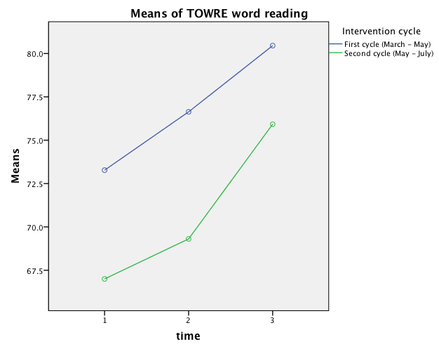

Figure 3: Pattern of mean TOWRE non-word reading standard scores
(no significant interaction)
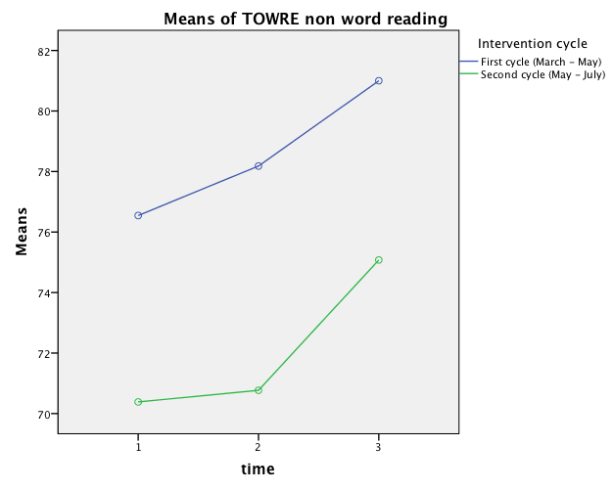

Figure 4: Pattern of mean BAS word reading age scores
(significant interaction between group over time)

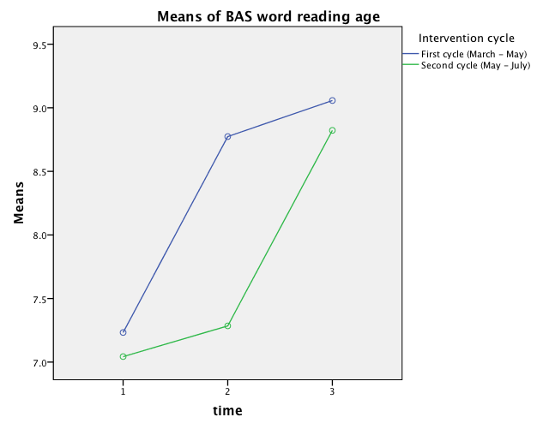

Figure 5: Pattern of mean LUCID phonological processing scores
(no significant time or interaction of time by groups)
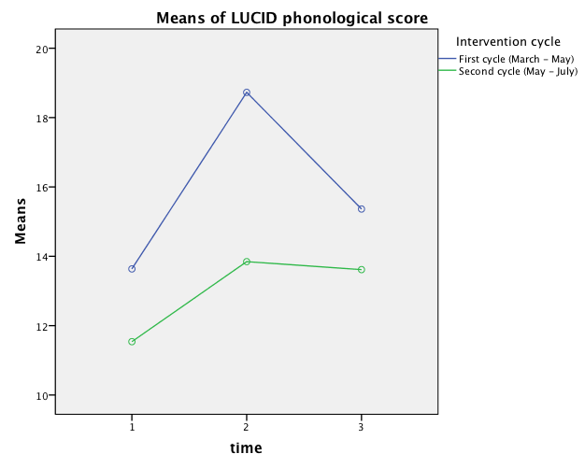

Figure 6: Pattern of mean LUCID phonic decoding)
(no significant time or interaction of time by groups)
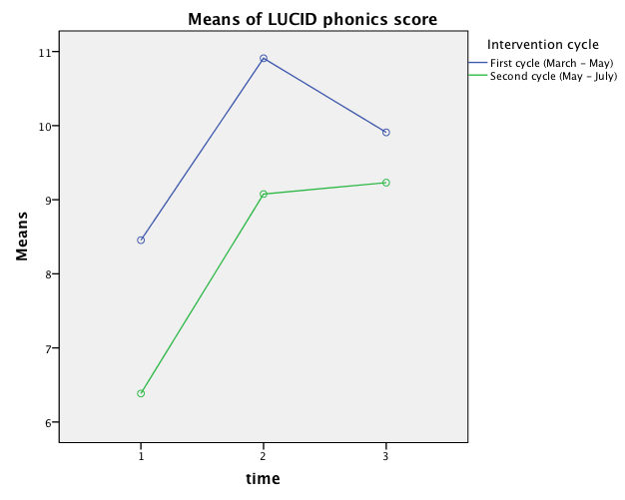

A ratio gain is a group’s average gain in reading age in months divided by the time between pre- and post-test in months. A ratio gain of 1.0 is exactly standard progress. Brooks (2007) regards a ratio gain of 4 or greater to be ‘remarkable’, 3 to 4 ‘substantial impact’, 2 to 3 ‘useful impact’, 1.4 to 2 ‘modest impact’, and below 1.4 to be ‘impact of doubtful educational significance’.

