MINUTES FROM THE

SPIDAS 2nd PARTNER MEETING

Monday 21 May 2018, Exeter, UK

Room
Baring Court Room 06 and 07, St Luke’s Campus, University of Exeter, Heavitree Road, Exeter

In attendance
Andrew Dean, Taro Fujita, Nasser Mansour, Ben Neild, Ed Horncastle, Stuart Allen, Matthew Pitts, Stephen Coaker, Jordi Espasa, David Escola, Iolanda Mateu, Anicet Cosialls, Rosa Borrell, Felicity Liggins, Rukiye Gokce, Esra Iymen Ikizoglu, Sibel Kazak, Andreea Cujba, Manoli Pifarre, Victor Molinet, Yesin Memis and Silvia Cierco Seira.

Apologies
Steve Brown, St James School (who attended on the 22nd).

Minutes from the previous meeting
These were accepted.

Welcome from Exeter and introductions from partners
The University of Exeter welcomed all of the participants to the meeting and ran through the Agenda. All partners introduced themselves, their institutions and their roles within them.
Update on the Project Management and Work Package 1
Dr Andrew Dean, University of Exeter, ran through the WP activities.

Partners had been supplying the information as requested for the financial record keeping and reporting and AD would be in touch again soon for the March – May timesheets. Any outstanding letters of employment should be sent to the University of Exeter asap.
The Project poster/flyer was available on the DROP-BOX and had been distributed by AD. The partners had been in regular skype contact between the HEIs and were working closely between the partner national organisations.

Taro had set up the Project webpages/blog.

ACTIONS and CONCLUSIONS
- Any letters of employment not all ready with the University of Exeter to be sent asap
- Andrew Dean to request latest electronic timesheets in early JUNE 2018
- All partners to keep a record of all dissemination activities and to pass evidence of these to the University of Exeter
- Andrew Dean to set up a twitter account for the project by Summer 2018
- Andrew Dean to send updated posters to all partners by 1st of June 2018
- All partners – respond to blog posts when appropriate.
- All partners - link to the project website from their own websites
- Andrew Dean and Taro Fujita to explore putting a twitter feed into the Wordpress blog
- All partners to respond to AD requests regarding the INTERIM Evaluation which would take place on 1/11/2018

Work Package 2
Copies of the PowerPoint slides used are available via the Drop Box account.
Dr Taro Fujita, University of Exeter introduced the work carried out to date within WP2 and the HEI partners from Turkey and Spain also summarised their work identifying the state of the art. Discussions revolved around:
- Innovative practices that could be built-on by pilots
- Issues vis-a-via project design
- Teacher training needs
- Data requirements
- Actions and Deadlines
The partners were finalising the State of the Art Reviews will be a series of three written reports, one for each partner country, describing innovative and effective practices relating to the teaching of data analytics in school age education. To achieve this there had been:
- Lliterature review of existing knowledge in the teaching and learning of data analytics from research / professional journals (national / international)
- Informal interview/focus group interview to the project partners
- Questionnaires to students what they are interested in based on teachers’ interview
- Online discussion in Blog
- Links to other EU projects: Previous ERASMUS+ project
The project had accepted a definition of data Analytics of:
“engaging creatively in exploring data, including big data, to understand our world better, to draw conclusions, to make decisions and predictions, and to critically evaluate present/future courses of actions”.
Innovative teaching approaches (Cobb and McClain, 2004)
- Focus on developing central statistical ideas
- Use real and motivating data sets
- Use classroom activities to support the development of students’ reasoning.
- Integrate the use of appropriate technological tools
- Promote classroom discourses
- Use assessment to learn what students know and to monitor the development of their learning (Garfield & Ben-Zvi, 2009, p. 73)
Students’ interests in weather/climate change & attitudes towards statistics
- Initial survey results from each country were presented.
- In general our students seem to be interested in issues related to weather / climate change and they feel they need to take actions
- For example, UK students have relatively low anxieties and rather positive attitudes towards studying statistics, but their attitudes towards using applying and resilience can be improved. Perhaps it would be really useful if they can appreciate how knowledge and techniques related to statistics can be used in every life and jobs?
- It is also important to include both Positive-Negative narrative about weather, climate, climate change​

Technological tool
- CODAP (http://codap.concord.org/ ): Students can load their own data into an easy-to-use web-based data analysis tool to create their own datasets, share visualizations, and discover data-driven insights. In the process, they will learn to understand the world through its data.
Based on the State of the Art Reviews and the definition of data analytics (DA) accepted for the project, a conceptual framework for DA to guide the project pilots in schools was introduced and discussed. Revisions were proposed to refine the framework.
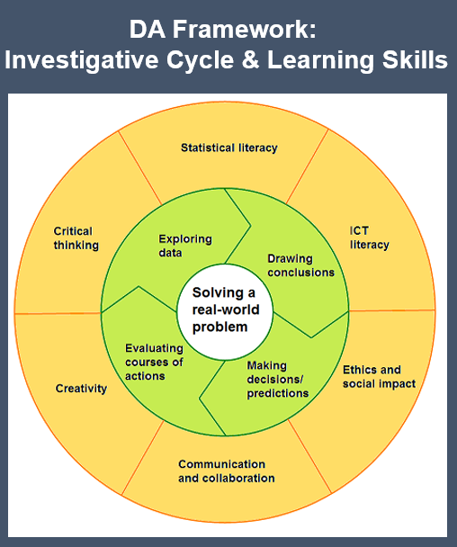
What data to be used and what topic do we want our students to engage?
Primary
- Possible theme: How does weather affect our town/city or health?
- Starting October 2018 & end December 2018 for the first pilot
- Weather data + data from students’ questions
- Process: Define problem – Plan and collect - Explore data – Draw conclusions – Make decisions – Evaluation
- Statistical concepts/skills/ideas: Averages, totals, tables, graphs, spread, proportion/%
- Technological tools: Excel, CODAP
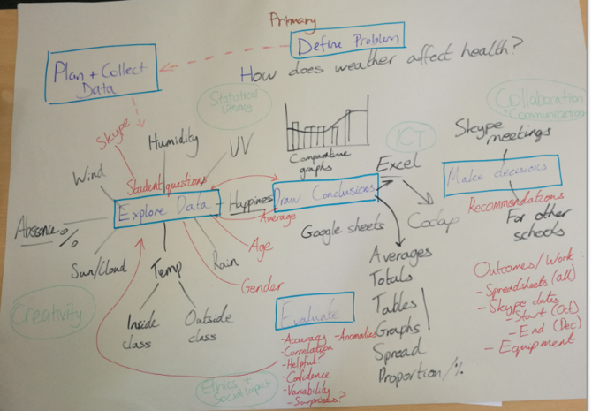
Secondary (11-16)
- Possible theme: How does the weather shape teenagers’ school attendance?
- Weather data (from Met office): Night time /day time temperature, humidity, rain, wind strength and snow?
- School data: Attendance report, absence, gender for last 5 years?
- Process: Define problem – Plan and collect (what valuables?) - Explore data (scatter graphs, correlation) – Draw conclusions – Make decisions – Evaluation
- Technological tools: Excel, CODAP

Post 16
- Possible theme: Uncertainty, meaning of data, modelling related to weather, Data comparison and how to communicate their data, findings, etc.
- Data from Met office: position and time, historical data and methodology of data collection + students’ own data
- Statistical concepts: Central limit theorem, standard deviations, etc.
- EMS: 90 min x 3 sessions? Uncertainly and simulating based on data and models.
- Exeter College: air pollution and students’ attendance, motor transport, illness (about 9-12 hours)
- Possible technological tools: Excel, Curveexpert, trachker, R, CODAPP, etc.

Introduction to Work Packages 3 and 4
Copies of the PowerPoint slides used are available via the Drop Box account.
Dr Taro Fujita introduced the Work Packages and considerable time was spent on both days exploring the work to be done within WP3 and WP4. Taro explored how this follows on logically from what we have found in the work to date in WP2.

SPIDAS 2nd PARTNER MEETING

Tuesday 22 May 2018, Exeter, UK

Agenda

Room
Baring Court Room 06, St Luke’s Campus, University of Exeter, Heavitree Road, Exeter

In attendance
Andrew Dean, Taro Fujita, Nasser Mansour, Ben Neild, Ed Horncastle, Stuart Allen, Steve Brown, Matthew Pitts, Stephen Coaker, Jordi Espasa, David Escola, Iolanda Mateu, Anicet Cosialls, Rosa Borrell, Felicity Liggins, Rukiye Gokce, Esra Iymen Ikizoglu, Sibel Kazak, Andreea Cujba, Manoli Pifarre, Victor Molinet, Yesin Memis and Silvia Cierco Seira

Group Work 1. The structure and content for the WP 3 Pilots.
Copies of the PowerPoint slides used are available via the Drop Box account.
All partners worked in intensive group discussions to finalise the content and structure for the School Pilots.

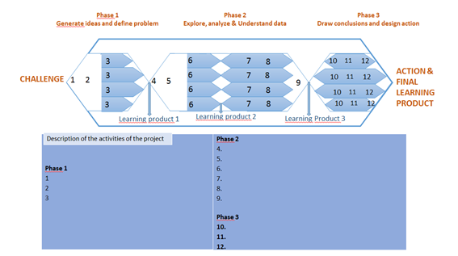

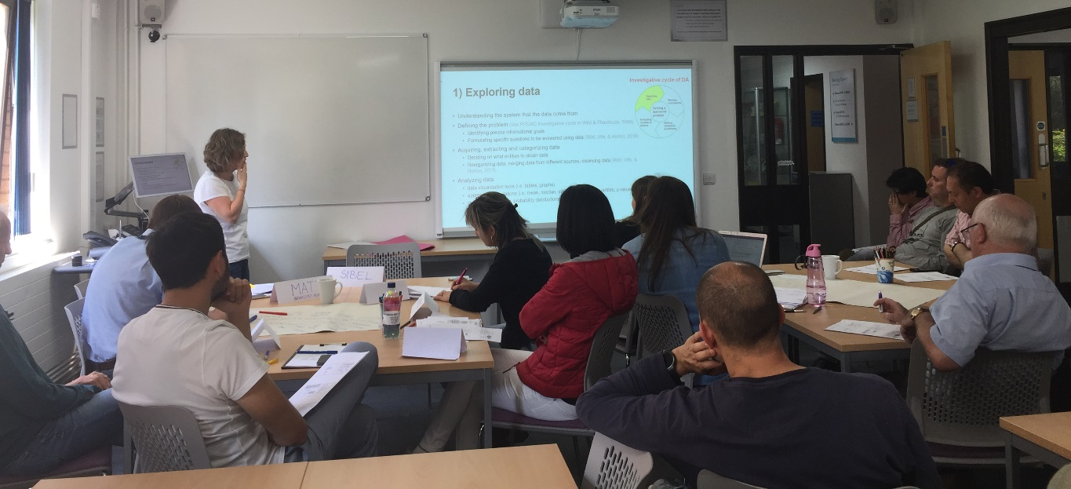

ACTIONS and CONCLUSIONS
- The University and School partners need to finalise their plans for the Pilot work and get this to University of Exeter by 1/7/2018

Group Work 2. The focus and approach for WP 4 pilot project evaluation.
Copies of the PowerPoint slides used are available via the Drop Box account.
WP4 will collect and analyse scientific evidences that could report about how the innovative and good practices designed and implemented have had an impact on students’ development of DA skills and on teachers’ practises.
In relation to the evaluation of the impact of the innovative and good practices designed, we agreed on developing evaluation tools to be used in three different moments: 1) before the implementation of the projects; 2) during the implementation of the projects and 3)after the implementation of the projects.
We agreed to develop the next evaluation tools and to evaluate the next variables related with students’ development:
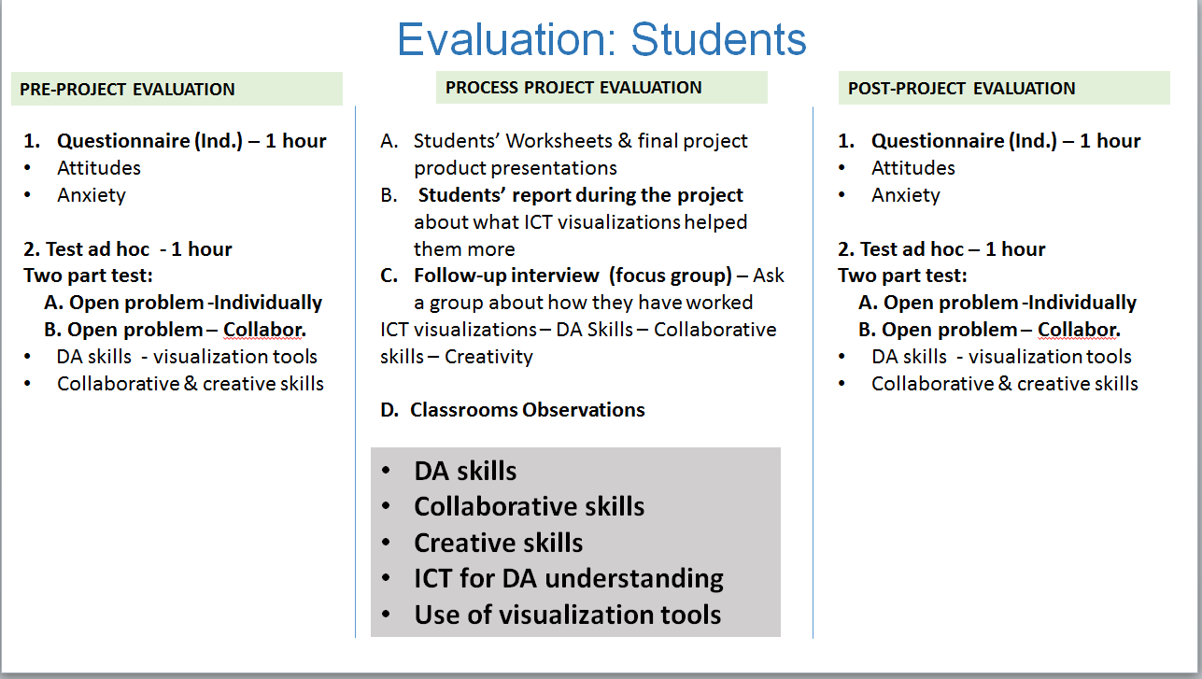
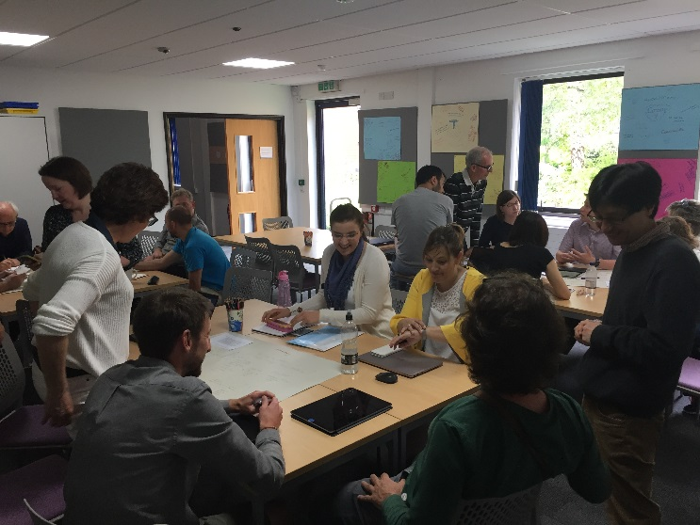
An example for evaluating students with an open problem from Primary education group:
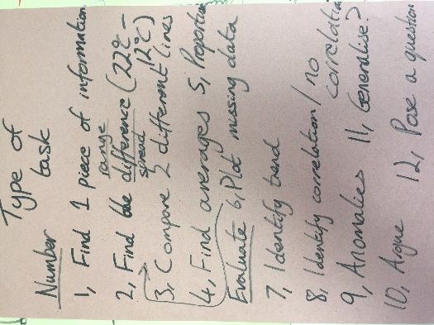

ACTIONS and CONCLUSIONS
- The University partners need to agree the tools and the content for the evaluation of students’ learning and development of DA skills by 15-09-2018
- The University partners need to agree the tools and the content for the evaluation of teachers’ professional development by 15-09-2018

Impact+ Evaluation - all partner exercise
Dr Andrew Dean, University of Exeter gave a presentation on the IMPACT+ Exercise and the participants created an Impact+ model.

ACTIONS and CONCLUSIONS
- Andrew Dean to circulate the results of the Impact+ exercise
- ALL partners to discuss these in their national meetings and to feedback on content ahead of the INTERIM Evaluation

Any other business and Steering Group
The partners were happy with progress on the project.

Date and venue for the next meeting
The next meeting would be held at the University of Lleida on January 14 and 15 with participants travelling in advance on Sunday 13th January.

