SWSBC 2021 Abstract submission form, return by Wednesday 30th June 2021

Presenter Name
Presenter Email
Laboratory / PI
Mail address
Presentation type preferred: oral or poster oral and poster poster only

Presentation type: ticking any option containing “oral” as presentation type means your abstract will be forwarded to the program committee for selection. If you tick “oral and poster” you must prepare a talk and a poster, and this option gives you additional time to discuss your results in the poster session (recommended).
- Talks are 10 Minutes plus 5 minutes discussion.
- Posters are in 16:10 widescreen format. You need to
  - submit your poster as pdf
  - submit a narrated PowerPoint of your poster
  - prepare a 3-minute poster pitch, to be scheduled for the poster pitch session
  - explain your poster to visitors and answer their questions in your own scheduled online channel during the poster session

Please find the abstract template for oral / poster presentations attached.

All abstracts will be published on the meeting website.

Thank you for submitting your work!

Oral and poster abstract template. Please replace the text and return by 30.6.2021.

Title
Study of Immune Receptors by Combination of Crystallography, SAXS and Computational Chemistry

Authors; underline presenting author
Emma Sutton, Hayden Fisher, Chris Orr, Richard Bradshaw, Mark Cragg, John Essex & Ivo Tews

Affiliation/s
Biological Sciences, Institute for Life Sciences B85, University of Southampton, Southampton, SO17 1BJ

Abstract; 150w max
Biologics are biomolecular drugs, comprising five of the top-ten blockbuster pharmaceuticals. Eighty percent of these Biologics are monoclonal antibodies now ubiquitous in the treatment of human disease ranging from cancer to autoimmune disorders. To understand the molecular mechanisms of immune regulation we study antibodies, antibody fragments, and immune receptor complexes combining crystallographic structure analysis with small angle X-ray scattering in-solution studies. We have predicted theoretical scattering profiles for atomistic structures extracted from molecular dynamics (MD) simulations; the motions observed during the MD trajectory were extracted through principal component analysis, followed by assessment of the agreement of structures with experimental SAXS data. The method does not only allow detection of global changes but is able to pinpoint local changes in specific loop regions of the antibody fragment. The methodology described is generally applicable to deconvolute global and local changes of macromolecular structures and well suited to other systems.

Graphical Abstract
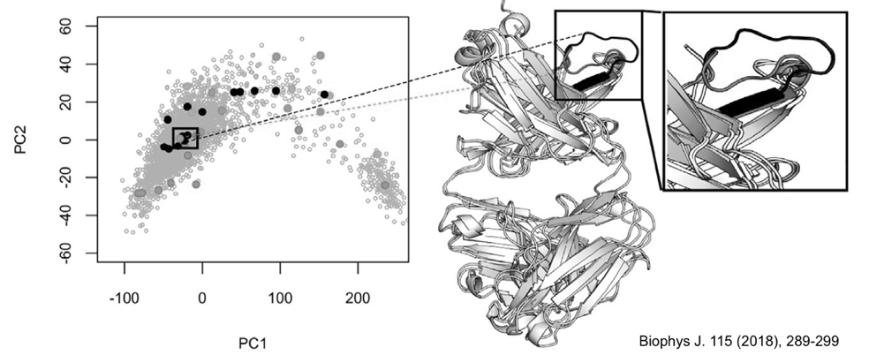

Primary citation (make sure to link to the online publication)
- Sutton EJ, Bradshaw RT, Orr CM, Frendéus B, Larsson G, Teige I, Cragg MS, Tews I, Essex JW. “Evaluating Anti-CD32b F(ab) Conformation Using Molecular Dynamics and Small-Angle X-Ray Scattering.” Biophys J. 2018 Jul 17;115(2):289-299. doi: 10.1016/j.bpj.2018.03.040.

Up to three references (make sure to link to the online publications)
- Yu X, Chan HTC, Orr CM, Dadas O, Booth SG, Dahal LN, Penfold CA, O'Brien L, Mockridge CI, French RR, Duriez P, Douglas LR, Pearson AR, Cragg MS, Tews I, Glennie MJ, White AL. “Complex Interplay between Epitope Specificity and Isotype Dictates the Biological Activity of Anti-human CD40 Antibodies.” Cancer Cell. 2018 Apr 9;33(4):664-675.e4. doi: 10.1016/j.ccell.2018.02.009.
- Willoughby J, Griffiths J, Tews I, Cragg MS. “OX40: Structure and function - What questions remain?” Mol Immunol. 2017 Mar;83:13-22. doi: 10.1016/j.molimm.2017.01.006.
- Mansour S, Tocheva AS, Cave-Ayland C, Machelett MM, Sander B, Lissin NM, Molloy PE, Baird MS, Stübs G, Schröder NW, Schumann RR, Rademann J, Postle AD, Jakobsen BK, Marshall BG, Gosain R, Elkington PT, Elliott T, Skylaris CK, Essex JW, Tews I, Gadola SD. “Cholesteryl esters stabilize human CD1c conformations for recognition by self-reactive T cells.” Proc Natl Acad Sci U S A. 2016 Mar 1;113(9):E1266-75. doi: 10.1073/pnas.1519246113.

